1

Laineil Chen 陳建廷 2021.03.29_v11

**SAS Viya 3.5 for Linux  
MPP with HA  
Deployment Guide**

**目錄**

**1.** **準備安裝任務** 4

1.1 Linux Server服務規劃 4

1.2 事前準備檔案(control01) 4

1.3 特殊目錄結構(all) 5

1.4 事前準備檔案路徑(control01) 5

1.5 設定hostname(control01) 6

1.6 建立ssh金鑰配對(control01, control02) 7

1.7 配置Local Ansible Repository(control01, control02) 7

1.8 安裝Ansible(control01, control02) 8

1.9 定義ansible hosts(control01, control02) 9

1.10 安裝oracle client(control01) 11

1.11 建立cache目錄(control01) 11

1.12 建立saswork目錄(control01) 11

1.13 系統檢查(control01) 12

**2.** **開始安裝任務** 14

2.1 配置inventory.ini(control01) 14

2.2 配置host_vars(control01) 14

2.3 配置vars.yml(control01) 15

2.4 Pre-install Check(control01) 17

2.5 /opt soft link(control01) 21

2.6 Share mount for cas(control01, control02) 21

2.7 清空Yum cache 22

2.8 安裝SAS Viya(control01) 22

2.9 Disable Viya Auto Start(control01) 23

**3.** **安裝後任務** 24

3.1 Post Configuration 24

3.2 設定SAS Environment Manager管理者sasboot 25

3.3 調整SAS Viya常用Service的Log Level 30

3.4 確認SAS Viya Service狀態 33

3.5 驗證SAS Viya版本 34

3.6 確認SAS Liciense Products 35

3.7 設定AD連線SAS Environment Manager 35

3.7.1 配置sas.identities.providers.ldap.connection 36

3.7.2 配置sas.identities.providers.ldap.group 38

3.7.3 配置sas.identities.providers.ldap.user 40

3.7.4 驗證AD連線SAS Environment Manager 43

3.7.5 Linux加入AD網域 47

3.8 配置SAS Environment Manager管理者 51

3.8.1 配置Application Administrators 51

3.8.2 配置SAS Administrators 53

3.8.3 驗證administrators配置 54

3.9 SAS Environment Manager備份功能 56

3.9.1 配置SAS EnvironmentManager備份路徑(control01) 56

3.9.2 測試SAS EnvironmentManager備份 58

3.10 測試連線Oracle DB 61

3.11 測試SAS StudioV功能 62

**4.** **增加CAS Server** 68

4.1 Pre-installation 68

4.2 Copy and Modify file 68

4.3 Run ansible 70

4.4 Post-installation 70

**5.** **Viya系統監控** 72

5.1 Monitor Script 72

5.2 Auto Backup and Restore CAS data 73

5.3 House keeping 75

5.4 Server Monitor Report 75

**6.** **Viya服務管理** 82

6.1 查詢Viya服務狀態 82

6.2 關閉Viya所有服務 85

6.3 開啟Viya所有服務 86

6.4 重啟Viya所有服務 87

6.5 Load CAS Tables 88

**7.** **更新授權** 89

7.1 上傳新授權 89

7.2 修改vars.yml 90

7.3 啟用新授權 91

**8.** **NAS更換步驟** 92

8.1 Stop all viya service(control01) 92

8.2 Mount new NAS and change owner(control01) 92

8.3 Copy files(control01) 92

8.4 Set up NAS(control01,control02) 92

8.5 Start viya service(control01) 92

8.6 Revised /etc/fstab(control01,control02) 92

**9.** **Error Logs查詢** 93

9.1 SAS Environment Manager Los 93

9.2 SAS Server Logs 95

9.3 Log Collection Script 95

# **準備安裝任務**

## Linux Server服務規劃

|  |  |  |  |  |  |  |  |
| --- | --- | --- | --- | --- | --- | --- | --- |
| **Server Role** | **Host Name** | **IP Address** | **OS Version** | **CPU** | **RAM** | **SAS Cache Location** | **SAS binary Location** |
| load balance | balance | 10.70.12.20 | Redhat7.8 | 8 cores | 32 GiB | none | none |
| cas controller | control01 | 10.70.12.21 | Redhat7.8 | 16 cores | 64 GiB | /cache0/sascache01~80 | /opt/sas |
| backup cas controller | control02 | 10.70.12.22 | Redhat7.8 | 16 cores | 64 GiB | /cache0/sascache01~80 | /opt/sas |
| micro service | micro01 | 10.70.12.23 | Redhat7.8 | 32 cores | 128 GiB | /cache0/sascache01~80 | /opt/sas |
| micro service | micro02 | 10.70.12.24 | Redhat7.8 | 32 cores | 128 GiB | /cache0/sascache01~80 | /opt/sas |
| micro service | micro03 | 10.70.12.25 | Redhat7.8 | 32 cores | 128 GiB | /cache0/sascache01~80 | /opt/sas |
| PostgreSQL HA vip | pqsqlvip | 10.70.12.26 | On micro | On micro | On micro | On micro | On micro |
| cas worker | worker01 | 10.70.12.27 | Redhat7.8 | 32 cores | 256 GiB | /cache0/sascache01~80 | /opt/sas |
| cas worker | worker02 | 10.70.12.28 | Redhat7.8 | 32 cores | 256 GiB | /cache0/sascache01~80 | /opt/sas |
| cas worker | worker03 | 10.70.12.29 | Redhat7.8 | 32 cores | 256 GiB | /cache0/sascache01~80 | /opt/sas |

## 事前準備檔案(control01)

1. sas_repos

* -sas_repos_tsmc_2011.tar.part.xx

1. sas_viya_playbook_tsmc_2011.tgz
2. oracle-client

* oracle-instantclient19.3-basic-19.3.0.0.0-1.x86_64.rpm
* oracle-instantclient19.3-sqlplus-19.3.0.0.0-1.x86_64.rpm

1. rhel-7-server-ansible-2.8-rpms.tar

## 特殊目錄結構(all)

|  |  |
| --- | --- |
| 目錄 | 功用 |
| /CREPOS | Mount point of share storage(NAS) |
| /userap | Extra disk for /opt/sas link |

## 事前準備檔案路徑(control01)

解開事前準備檔案

|  |
| --- |
| [root@control01 ~]# cat sas_repos_tsmc_2011.tar.part.* > sas_repos_tsmc_2011.tar  [root@control01 ~]# tar xvf sas_repos_tsmc_2011.tar  [root@control01 ~]# tar zxvf sas_viya_playbook_tsmc_2011.tgz  [root@control01 ~]# tar zxvf rhel-7-server-ansible-2.8-rpms.tar |

將檔案放至對應位置

|  |  |
| --- | --- |
| 準備檔案 | 路徑位置 |
| Viya源檔案 | /CREPOS/sas_repos |
| Local Ansible Repository | /CREPOS/rhel-7-server-ansible-2.8-rpms |
| 安裝工具 | /CREPOS/viya_35c |
| 安裝所需腳本 | /CREPOS/viya_35c/sas_viya_playbook |
| Oracle client | /CREPOS/viya_35c/oracle_client |

## 設定hostname(control01)

設定主機名稱解析

|  |
| --- |
| [root@control01 ~]# vim /etc/hosts  10.70.12.20 balance.lzone.org balance  10.70.12.21 control01.lzone.org control01  10.70.12.22 control02.lzone.org control02  10.70.12.23 micro01.lzone.org micro01  10.70.12.24 micro02.lzone.org micro02  10.70.12.25 micro03.lzone.org micro03  10.70.12.27 worker01.lzone.org worker01  10.70.12.28 worker02.lzone.org worker02  10.70.12.29 worker03.lzone.org worker03 |

驗證主機名稱解析

|  |
| --- |
| [root@control01 ~]# hostname -f  [root@control01 ~]# hostname -i  [root@control01 ~]#hostname -s |

發送hosts

|  |
| --- |
| [root@control01 ~]# scp /etc/hosts *[all_nodes]*:/etc/ |

## 建立ssh金鑰配對(control01, control02)

control01

|  |
| --- |
| [root@control01 ~]# ssh-keygen -q -t rsa -N '' -f ~/.ssh/id_rsa  [root@control01 ~]#  ssh-keyscan $(awk '{print $1}' /etc/hosts | grep '10.70.12') >> ~/.ssh/known_hosts  [root@control01 ~]# ssh-keyscan $(awk '{print $2}' /etc/hosts | grep '^[cmw]') >> ~/.ssh/known_hosts  [root@control01 ~]# ssh-keyscan $(awk '{print $3}' /etc/hosts | grep '^[cmw]') >> ~/.ssh/known_hosts  [root@control01 ~]# ssh-copy-id *[all_nodes]*  [root@control01 ~]# scp ~/.ssh/id_rsa* control02:~/.ssh/ |

control02

|  |
| --- |
| [root@control02 ~]#  ssh-keyscan $(awk '{print $1}' /etc/hosts | grep '10.70.12') >> ~/.ssh/known_hosts |

control01, control02驗證

|  |
| --- |
| # ssh *[all_nodes]* |

## 配置Local Ansible Repository(control01, control02)

配置repo設定檔

|  |
| --- |
| # vim /etc/yum.repos.d/ansible_local.repo  [ansible_local]  name=ansible local source  baseurl=file:///CREPOS/rhel-7-server-ansible-2.8-rpms  gpgcheck=0  enabled=1 |

驗證配置完成

|  |
| --- |
| # yum repolist |

Note : 檢查Red Hat Linux repo已掛上，若無可請CCD協助處理。

## 安裝Ansible(control01, control02)

|  |
| --- |
| # yum install ansible-2.8.6 |

驗證anisble安裝版本

|  |
| --- |
| # ansible --version |

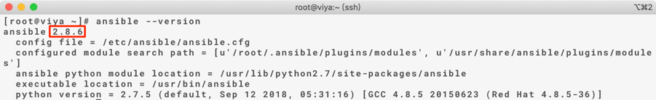

驗證anisble安裝完成

|  |
| --- |
| # ansible localhost -m ping |

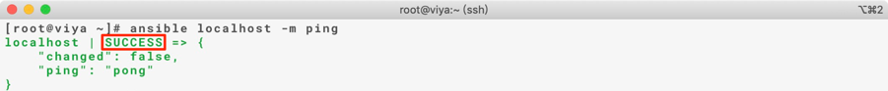

## 定義ansible hosts(control01, control02)

[node] 為不包含本機的所有server資訊，[cluster] 為包含本機的所有server資訊

[cas]為包含cas server及cas worker的所有server資訊，[controller]為包含primary及backup controller的所有server資訊，[worker] 為包含cas worker的所有server資訊，[microservice]為包含所有microervice的所有server資訊，[gpu]為包含cas worker的所有server資訊。

control01

|  |
| --- |
| [root@control01 ~]# vim /etc/ansible/hosts  [node]  10.70.12.[22:25]  10.70.12.[27:29]  [cluster]  10.70.12.[21:25]  10.70.12.[27:29]  [cas]  …  [controller]  …  [worker]  …  [microserivce]  …  [gpu]  … |

control02

|  |
| --- |
| [root@control01 ~]# vim /etc/ansible/hosts  [node]  10.70.12.21  10.70.12.[23:25]  10.70.12.[27:29]  [cluster]  10.70.12.[21:25]  10.70.12.[27:29]  [cas]  …  [controller]  …  [worker]  …  [microserivce]  …  [gpu]  … |

驗證control01, control02

|  |
| --- |
| # ansible cluster -m shell -a 'hostname -f'  # ansible node -m shell -a 'hostname -s' |

## 安裝oracle client(control01)

|  |
| --- |
| [root@control01 ~]# ansible cluster -m shell -a 'rpm -ivh /CREPOS/viya_35c/oracle_client/oracle-instantclient19.3-basic-19.3.0.0.0-1.x86_64.rpm'  [root@control01 ~]# ansible cluster -m shell -a 'rpm -Uvh /CREPOS/viya_35c/oracle_client/oracle-instantclient19.3-sqlplus-19.3.0.0.0-1.x86_64.rpm' |

## 建立cache目錄(control01)

|  |
| --- |
| [root@control01 ~]# ansible cluster -m shell -a 'for (( i=1; i<=9; i=i+1 )); do mkdir -p /cache0/sascache0$i; done'  [root@control01 ~]# ansible cluster -m shell -a 'for (( i=10; i<=80; i=i+1 )); do mkdir /cache0/sascache$i; done'  [root@control01 ~]# ansible cluster -m shell -a 'chmod 777 /cache0/sascache*' |

Note : 檢查cache0都有mount上去

驗證sascache建立完成

|  |
| --- |
| [root@control01 ~]# ansible cluster -m shell -a 'ls -l /cache0/' |

## 1.12 建立saswork目錄(control01)

[root@control01 ~]# ansible cluster -m shell -a 'mkdir /cache0/saswork'

[root@control01 ~]# ansible cluster -m shell -a 'chmod 777 /cache0/saswork'



## 系統檢查(control01)

hostname

|  |
| --- |
| # ansible cluster -m shell -a 'hostname -f && hostnamectl status' |

OS version

|  |
| --- |
| # ansible cluster -m shell -a 'cat /etc/redhat-release' |

File System

|  |
| --- |
| # ansible cluster -m shell -a 'df -h /opt/userap/cache0/CREPOS/sas/home' |

fstab

|  |
| --- |
| # ansible cluster -m shell -a 'cat /etc/fstab' |

CPU

|  |
| --- |
| # ansible cluster -m shell -a 'lscpu | grep “CPU(s)”' |

RAM

|  |
| --- |
| # ansible cluster -m shell -a 'lsmem | grep Total' |

網卡

|  |
| --- |
| # ansible cluster -m shell -a 'ip addr show' |

NTP

確認 CHRONYD 服務為 stop 及 disabled

|  |
| --- |
| # ansible cluster -m shell -a 'systemctl status chronyd'  # ansible cluster -m shell -a 'systemctl disable chronyd' |

將 /etc/sysconfig/ntpd 中 OPTIONS=”-g -x” 更改為 OPTIONS=”-g” (更改原因ref: <https://access.redhat.com/solutions/3759171>)

|  |
| --- |
| # vi /etc/sysconfig/ntpd |

將設定檔複製到其他台 viya cluster，並重啟 ntpd 生效

|  |
| --- |
| # ansible CommandLine -i /CREPOS/viya_35c/sas_viya_playbook/inventory.ini  -m copy -a 'src=/etc/sysconfig/ntpd dest=/etc/sysconfig/ntpd'  # ansible CommandLine -i /CREPOS/viya_35c/sas_viya_playbook/inventory.ini  -m shell -a "systemctl restart ntpd" |

確認ntpd服務正常，等待 5-10分鐘後再往下進行

|  |
| --- |
| # ansible CommandLine -i /CREPOS/viya_35c/sas_viya_playbook/inventory.ini  -m shell -a "systemctl status ntpd" |

確認 ntpq 正常 (若是無標示 * 則等一段時間後再確認)

|  |
| --- |
| # ansible CommandLine -i /CREPOS/viya_35c/sas_viya_playbook/inventory.ini  -m shell -a "ntpq -pn" |

確認 ntp 狀態 (若非synchronised to NTP server 則等一段時間後再確認)

|  |
| --- |
| # ansible CommandLine -i /CREPOS/viya_35c/sas_viya_playbook/inventory.ini  -m shell -a "ntpstat" |

確認 ntp 狀態 (若非NTP synchronized: yes則等一段時間後再確認)

|  |
| --- |
| # ansible CommandLine -i /CREPOS/viya_35c/sas_viya_playbook/inventory.ini  -m shell -a "timedatectl" |

時區

|  |
| --- |
| # ansible cluster -m shell -a 'date' |

Java version

|  |
| --- |
| # ansible cluster -m shell -a 'rpm -qa | grep java' |

# **開始安裝任務**

## 配置inventory.ini(control01)

進入sas_viya_playbook目錄

|  |
| --- |
| [root@control01 ~]# cd /CREPOS/viya_35c/sas_viya_playbook |

設置inventory.ini

|  |
| --- |
| [root@control01 sas_viya_playbook]# vim inventory.ini  deployTarget01 ansible_host=micro01.lzone.org  deployTarget02 ansible_host=micro02.lzone.org  deployTarget03 ansible_host=micro03.lzone.org  cas-controller01 ansible_host=control01.lzone.org  cas-controller02 ansible_host=control02.lzone.org  cas-worker01 ansible_host=worker01.lzone.org  cas-worker02 ansible_host=worker02.lzone.org  cas-worker03 ansible_host=worker03.lzone.org |

## 配置host_vars(control01)

進入host_vars目錄

|  |
| --- |
| [root@control01 ~]# cd /CREPOS/viya_35c/sas_viya_playbook/host_vars |

|  |
| --- |
| [root@control01 sas_viya_playbook]# vim *[all_nodes]*.yml  ---  network_conf:  SAS_HOSTNAME: control01.lzone.org  SAS_BIND_ADDR: 10.70.12.21  SAS_SAN_DNS: "control01.lzone.org localhost"  SAS_SAN_IP: "127.0.0.1 10.70.12.21" |

## 配置vars.yml(control01)

進入sas_viya_playbook目錄

|  |
| --- |
| [root@control01 ~]# cd /CREPOS/viya_35c/sas_viya_playbook |

設定vars.yml配置

|  |
| --- |
| [root@control01 sas_viya_playbook]# vim vars.yml  CAS_SETTINGS:  1: ORACLE_HOME=/usr/lib/oracle/19.3/client64  2: JAVA_HOME=/usr/lib/jvm/jre-1.8.0  3: LD_LIBRARY_PATH=$LD_LIBRARY_PATH:$ORACLE_HOME/lib:$JAVA_HOME/lib/amd64/server  REPOSITORY_WAREHOUSE: "file:///CREPOS/sas_repos/"  - HA_PGPOOL_VIRTUAL_IP: '*[postgresql_ha_vip]*'  CAS_DISK_CACHE: /cache0/sascache01:/cache0/sascache02:/cache0/sascache03:/cache0/sascache04:/cache0/sascache05:/cache0/sascache06:/cache0/sascache07:/cache0/sascache08:/cache0/sascache09:/cache0/sascache10:/cache0/sascache11:/cache0/sascache12:/cache0/sascache13:/cache0/sascache14:/cache0/sascache15:/cache0/sascache16:/cache0/sascache17:/cache0/sascache18:/cache0/sascache19:/cache0/sascache20:/cache0/sascache21:/cache0/sascache22:/cache0/sascache23:/cache0/sascache24:/cache0/sascache25:/cache0/sascache26:/cache0/sascache27:/cache0/sascache28:/cache0/sascache29:/cache0/sascache30:/cache0/sascache31:/cache0/sascache32:/cache0/sascache33:/cache0/sascache34:/cache0/sascache35:/cache0/sascache36:/cache0/sascache37:/cache0/sascache38:/cache0/sascache39:/cache0/sascache40:/cache0/sascache41:/cache0/sascache42:/cache0/sascache43:/cache0/sascache44:/cache0/sascache45:/cache0/sascache46:/cache0/sascache47:/cache0/sascache48:/cache0/sascache49:/cache0/sascache50:/cache0/sascache51:/cache0/sascache52:/cache0/sascache53:/cache0/sascache54:/cache0/sascache55:/cache0/sascache56:/cache0/sascache57:/cache0/sascache58:/cache0/sascache59:/cache0/sascache60:/cache0/sascache61:/cache0/sascache62:/cache0/sascache63:/cache0/sascache64:/cache0/sascache65:/cache0/sascache66:/cache0/sascache67:/cache0/sascache68:/cache0/sascache69:/cache0/sascache70:/cache0/sascache71:/cache0/sascache72:/cache0/sascache73:/cache0/sascache74:/cache0/sascache75:/cache0/sascache76:/cache0/sascache77:/cache0/sascache78:/cache0/sascache79:/cache0/sascache80  CAS_VIRTUAL_HOST: '*[loadbalance_fqdn]*'  CAS_VIRTUAL_PROTO: ‘http’  CAS_VIRTUAL_PORT:80  cfg:  #gcport: 0  #httpport: 8777  port: *[cas_port]*  #colocation: 'none'  SERVICESBASEURL: 'http://*[loadbalance_fqdn]*'  # Creates a workspaceserver sasenv_deployment file  FOUNDATION_CONFIGURATION:  #1: '# Comment about KEY'  #2: KEY=value  1: ORACLE_HOME=/usr/lib/oracle/19.3/client64  2: TWO_TASK=ORACLE_SID  3: ORAENV_ASK=NO  4: SASORA=V9  5: PATH=$PATH:$ORACLE_HOME/bin  6: LD_LIBRARY_PATH=$LD_LIBRARY_PATH:$ORACLE_HOME/lib:$JAVA_HOME/lib/amd64/server  7: COMPUTESERVER_TMP_PATH=/cache0/saswork  # Creates a workspaceserver sasv9_deployment.cfg file  SASV9_CONFIGURATION:  #1: '/* Comment about OPTION */'  #2: 'OPTION value'  1: '/* this will send the SASWORK to the /saswork location */'  2: 'WORK /cache0/saswork' |

## Pre-install Check(control01)

進入sas_viya_playbook目錄

|  |
| --- |
| [root@control01 ~]# cd /CREPOS/viya_35c/sas_viya_playbook |

確認pre-install playbook

NTP設定

|  |
| --- |
| # vi /CREPOS/viya_35c/sas_viya_playbook/viya-ark/playbooks/pre-install-playbook/roles/viya-ark.preinstall/defaults/main.yml  packages_nicetohave:   * ntp   # - chrony |

|  |
| --- |
| # vi /CREPOS/viya_35c/sas_viya_playbook/viya-ark/playbooks/pre-install-playbook/roles/viya-ark.preinstall/tasks/pre.ntp_config.yml  ---  ####################################################################  ## NTP Check  ####################################################################  # Test harness:  # make it pass  # ansible-playbook viya_pre_install_playbook.yml -i inventory --tags ntp_config -e use_pause=0  # make it fail  #  - block:  ## block start  - name: Check if ntp service exists  stat: path=/usr/lib/systemd/system/ntpd.service  register: ntpd_service  - name: Ensures NTP service is started and enabled  service:  name: "{{ item }}"  state: started  enabled: yes  when: ntpd_service.stat.exists  with_items:  - ntpd  # - name: Make sure ntp is running  # systemd:  # state: started  # name: chronyd  # - name: Make sure ntp is enabled  # systemd:  # name: chronyd  # enabled: yes  # masked: no  ## block end  tags:  - fixable  - ntp_config |

nproc, nofile設定

|  |
| --- |
| # dealing with ulimits:  default_ulimits_dir: /etc/security/limits.d  ulimit_file_loc: /etc/security/limits.d/viya_3.5_limits.conf  ulimits:  -  comment: "#Added (1) for Viya Installation"  domain: "*"  item: nofile  type: "-"  use_max: true  use_min: false  value: 300000  -  comment: "#Added (2) for Viya Installation"  domain: "{{sas_user}}"  item: stack  type: "-"  use_max: true  use_min: false  value: 10240  -  comment: "#Added (3) for Viya Installation"  domain: "*"  item: nproc  type: "-"  use_max: true  use_min: false  value: 200000  -  comment: "Added (4) for SAS Viya VI Installation"  domain: "{{sas_user}}"  item: nofile  type: "-"  use_max: true  use_min: false  value: 300000  -  comment: "Added (5) for SAS Viya VI Installation"  domain: "{{sas_user}}"  item: nproc  type: "-"  use_max: true  use_min: false  value: 200000 |

Run Pre-install check(若/opt過小，導致chaeck fail。因步驟2.5會mount extra disk，故可skip此項檢查)

|  |
| --- |
| [root@control01 sas_viya_playbook]# ansible-playbook -i inventory.ini viya-ark/playbooks/pre-install-playbook/viya_pre_install_playbook.yml --skip-tags skipstrogefail |

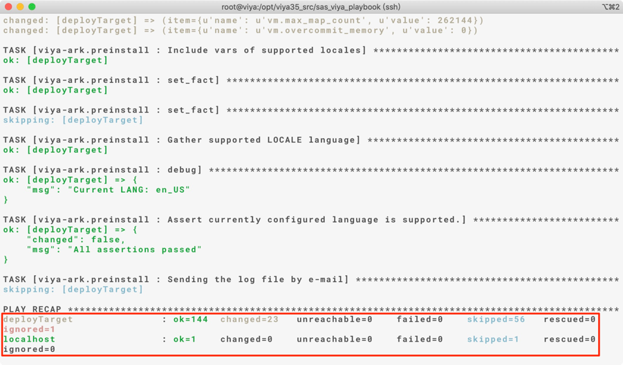

檢查pre-install config

|  |
| --- |
| [root@control01 ~]# ansible cluster -m shell -a ‘cat /etc/sysctl.conf | grep “kernel.sem”’  kernel.sem= 512 524288 256 1024 |

|  |
| --- |
| [root@control01 ~]# ansible cluster -m shell -a ‘cat /etc/security/limits.d/viya_3.5_limits.conf’  * - nofile 300000  sas - stack 10240  * - nproc 200000  sas - nofile 300000  sas - nproc 200000 |

重啟server以載入所有設定

|  |
| --- |
| [root@control01 ~]# ansible node -m shell -a 'reboot'  [root@control01 ~]# reboot |

確認重啟

|  |
| --- |
| [root@control01 ~]# ansible node -m shell -a 'uptime' |

## /opt soft link(control01)

|  |
| --- |
| [root@control01 ~]# ansible cluster -m shell -a 'rm -rf /opt/sas'  [root@control01 ~]# ansible cluster -m shell -a 'mkdir /userap/sas'  [root@control01 ~]# ansible cluster -m shell -a 'chown sas:sas /userap/sas'  [root@control01 ~]# ansible cluster -m shell -a 'ln -s /userap/sas /opt/sas' |

verify

|  |
| --- |
| [root@control01 ~]# ansible cluster -m shell -a 'ls -l /opt' |

## Share mount for cas(control01, control02)

control01

|  |
| --- |
| [root@control01 ~]# mkdir /CREPOS/caslib_info  [root@control01 ~]# chown sas:sas /CREPOS/caslib_info |

control01, control02

|  |
| --- |
| # mkdir -p /userap/sas/viya/config/data  # chown -R sas:sas /userap/sas  # ln -s /CREPOS/caslib_info /userap/sas/viya/config/data/cas |

verify

|  |
| --- |
| # ls -l /userap/sas/viya/config/data  # ls -l /opt/sas/viya/config/data |

## 清空Yum cache

|  |
| --- |
| [root@control01 ~]# ansible cluster -m shell -a 'yum clean all' |

## 安裝SAS Viya(control01)

進入sas_viya_playbook目錄

|  |
| --- |
| [root@control01 ~]# cd /CREPOS/viya_35c/sas_viya_playbook |

安裝前檢查system-assestment

[root@control01 sas_viya_playbook]# ansible-playbook -i inventory.ini site.yml system-assestment.yml

安裝SAS viya

|  |
| --- |
| [root@control01 sas_viya_playbook]# ansible-playbook -i inventory.ini site.yml |

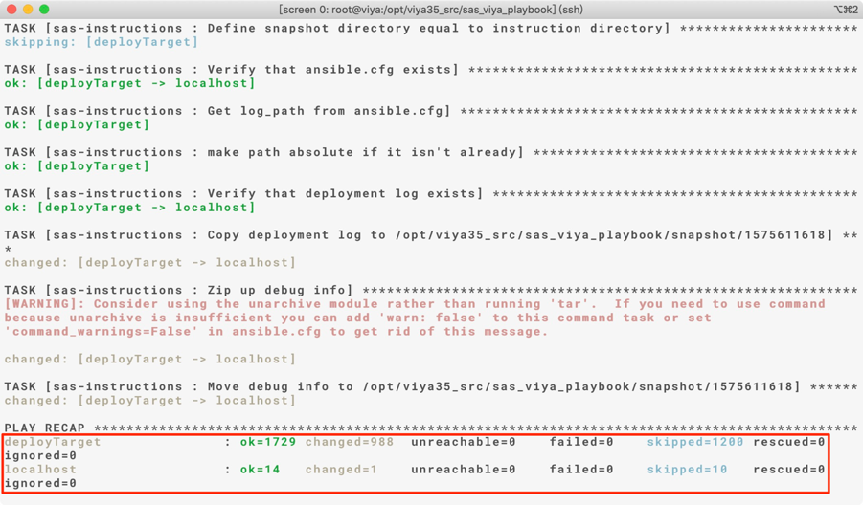

## Disable Viya Auto Start(control01)

進入sas_viya_playbook目錄

|  |
| --- |
| [root@control01 ~]# cd /CREPOS/viya_35c/sas_viya_playbook |

disable viya service auto start with server reboot

|  |
| --- |
| [root@control01 sas_viya_playbook]# ansible-playbook -i inventory.ini viya-ark/playbooks/viya-mmsu/viya-services-disable.yml |

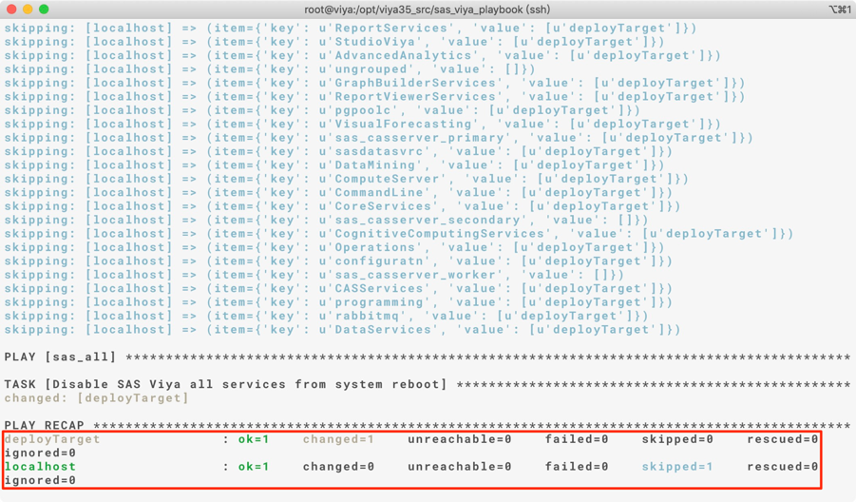

# **安裝後任務**

所使用的url請使用loadbalance提供

## Post Configuration

設定cas cgroup, cas monitor UI, load balance和maxtablemem

[Controller01] and [Controller02]

|  |
| --- |
| [root@control01 ~]# vi /opt/sas/viya/config/etc/cas/default/casconfig_usermods.lua  env.CAS_ENABLE_CONSUL_RESOURCE_MANAGEMENT=’TRUE’  cas.SERVICESBASEURL=’http://[load_balance]’  cas.MAXTABLEMEM=’536870912’ |

設定 workspace位置

[Microservie01~Microservice03]

|  |
| --- |
| #vi /opt/sas/spre/home/SASFoundation/sasv9_local.cfg  -WORK /opt/sas/spre/home/SASFoundation/sasv9work_list.cfg |

|  |
| --- |
| #vi /opt/sas/spre/home/SASFoundation/sasv9work_list.cfg  /cache0/saswork  method=space |

設定Apache time out時間

[Microservie01~Microservice03]

|  |
| --- |
| #vi /etc/httpd/conf.d/petrichor.conf  Timeout 3600 |

|  |
| --- |
| #systemctl restart httpd |

設定cmdui

[All Node]

Add the -cmdui=false to the “prod_options=” definition (near lines 148-149) along with the existing other options

|  |
| --- |
| #vi /opt/sas/viya/home/bin/sas-ops-agentclt  prod_options="runinit -port 7081 -path ${SASHOME}/bin -loquacity 3 \  -spoolpath ${SASCONFIG}/var/lib/evmcltsvcs/spool -cmdui=false" |

|  |
| --- |
| # sudo /etc/init.d/sas-viya-ops-agent-default restart |

[Microservice01]

|  |
| --- |
| #vi /opt/sas/viya/home/bin/sas-ops-agentsrv  prod_options="runinit -port 7082 -path ${SASHOME}/bin -role ETL -name ops-agentsrv -loquacity 3 \  -spoolpath ${SASCONFIG}/var/lib/evmsvrops/spoolsrv -servtype single -cmdui=false" |

|  |
| --- |
| #sudo /etc/init.d/sas-viya-ops-agentsrv-default restart |

設定dirty_ratio

[Controller01]

|  |
| --- |
| #ansible cluster -m shell -a 'echo -e "vm.dirty_background_ratio = 3\nvm.dirty_ratio = 10" >> /etc/sysctl.conf'  #ansible cluster -m shell -a 'sysctl -p' |

設定SAS/CAS 帳號密碼時效管理內容(需填寫ITSR單)

|  |
| --- |
| #ansible cluster -m shell -a 'sudo chage -I -1 -m 0 -M 99999 -E -1 sas'  #ansible cluster -m shell -a 'sudo chage -I -1 -m 0 -M 99999 -E -1 cas' |

檢查密碼時效管理內容

|  |
| --- |
| #ansible cluster -m shell -a 'sudo chage -I sas'  #ansible cluster -m shell -a 'sudo chage -I cas' |

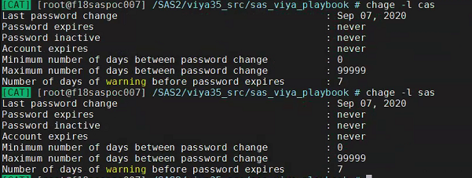

## 設定SAS Environment Manager管理者sasboot

sasboot為SASEnvironmentManager安裝好後暫時產生的管理者帳號,

登入任一台micro service node, grep重設sasboot密碼之url

|  |
| --- |
| [root@micro01 ~]# grep sasboot /var/log/sas/viya/saslogon/default/sas-saslogon_2019-12-06_01-26-42.log  # sas-saslogon_*[the lastest date]*.log |



[https://*[loadbalance_url]*/*[grep_url]*](https://[loadbalance_url]/%5bgrep_url%5d)

登入SASEnvironmentManager,

開啟瀏覽器, 建議使用firefox或chrome,

此處使用firefox為例, 輸入上方url,

點選”進階”=>點選”接受風險並繼續”

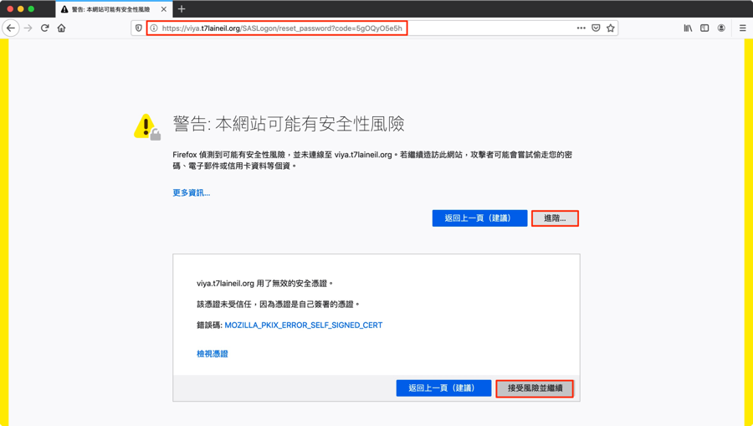

重設密碼, 此範例將密碼重設為”Orion123”

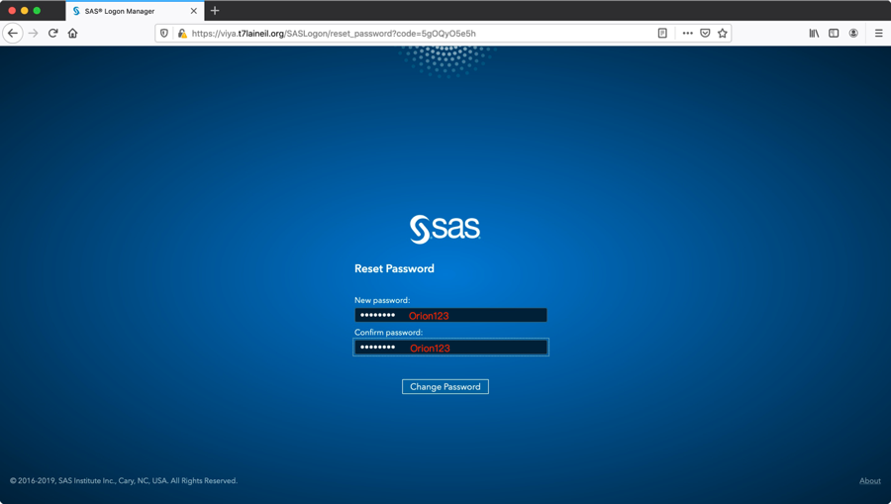

使用sasboot並搭配上面設定之密碼登入

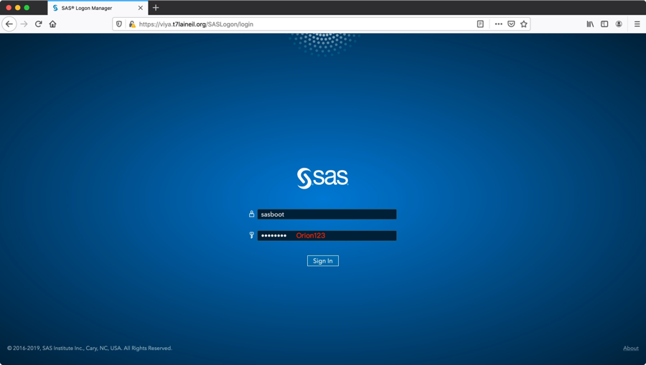

點選”是”, 加入可代入群組

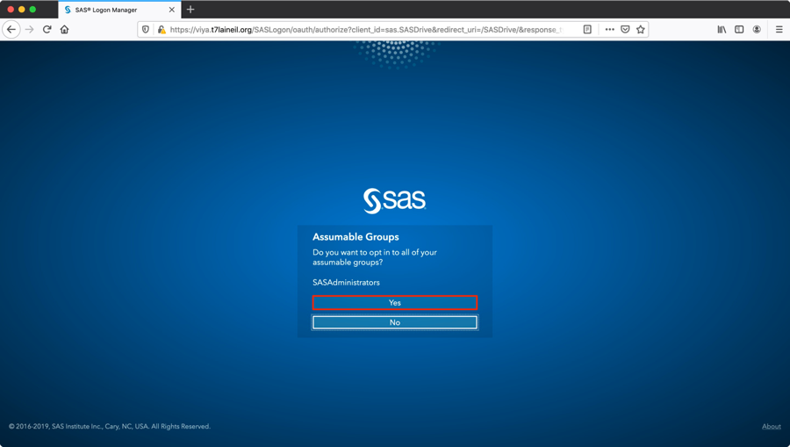

選擇主題設定或略過

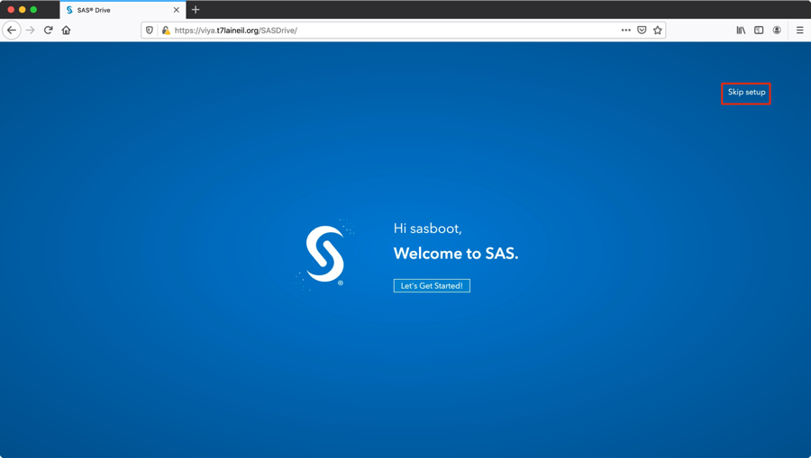

初次登入sasboot預設畫面

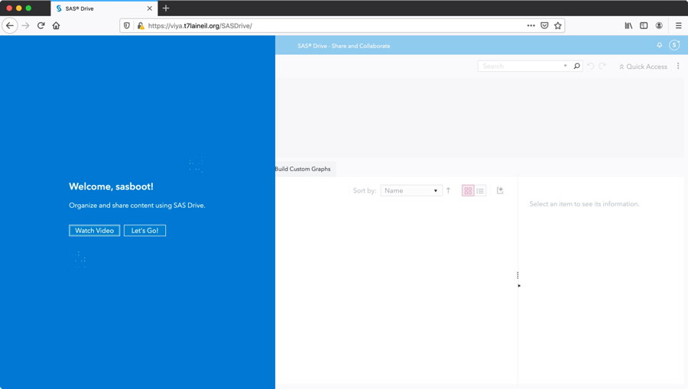

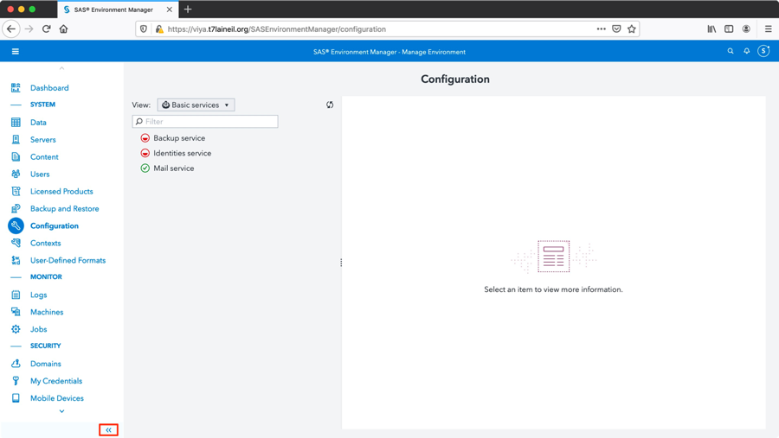

## 調整SAS Viya常用Service的Log Level

**設定TKPHAT(Tracing worker lost use)**

Controller01 and Controller02

|  |
| --- |
| [root@control01 ~]#mkdir -p /CREPOS/tklog  [root@control01 ~]#vi /opt/sas/viya/config/etc/cas/default/cas_usermods.settings  export TKPHAT="-debugfile /CREPOS/tklog/`date +"%Y-%m-%d-%H%M%S"`_$HOSTNAME-TK%t%p tracktkt" |

All Worker

|  |
| --- |
| [root@worker01 ~]#vi /opt/sas/viya/config/etc/cas/default/cas_usermods.settings  export TKPHAT="-debugfile /CREPOS/tklog/`date +"%Y-%m-%d-%H%M%S"`_$HOSTNAME-TK%t%p tracktkt" |

**設定Job Execution Service Log level by SAS Environment Manager**

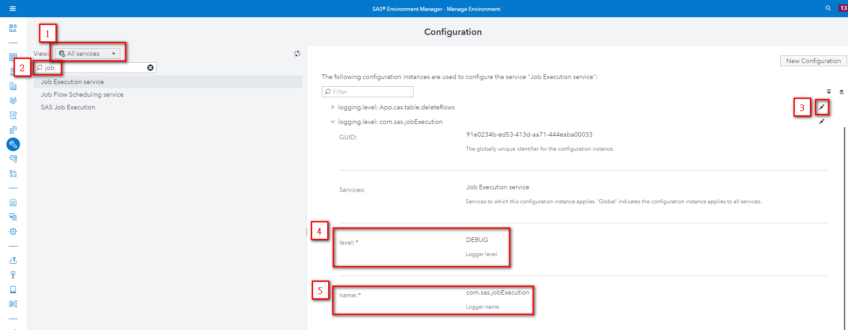

1: Select ‘All Services’

2: Search ‘job’

3: Choose Job Execution service and click ‘Edit’

4: Edit level to ‘DEBUG’

5: Edit name to ‘com.sas.jobExecution’

Note: 如果找不到configuration, 點選 ‘New Configuration’新增configuration

6: 至micro01重啟sas-viya-jobexecution-default

|  |
| --- |
| # systemctl restart sas-viya-jobexecution-default |

**設定Job Flow Scheduling Service Log level by SAS Environment Manager**

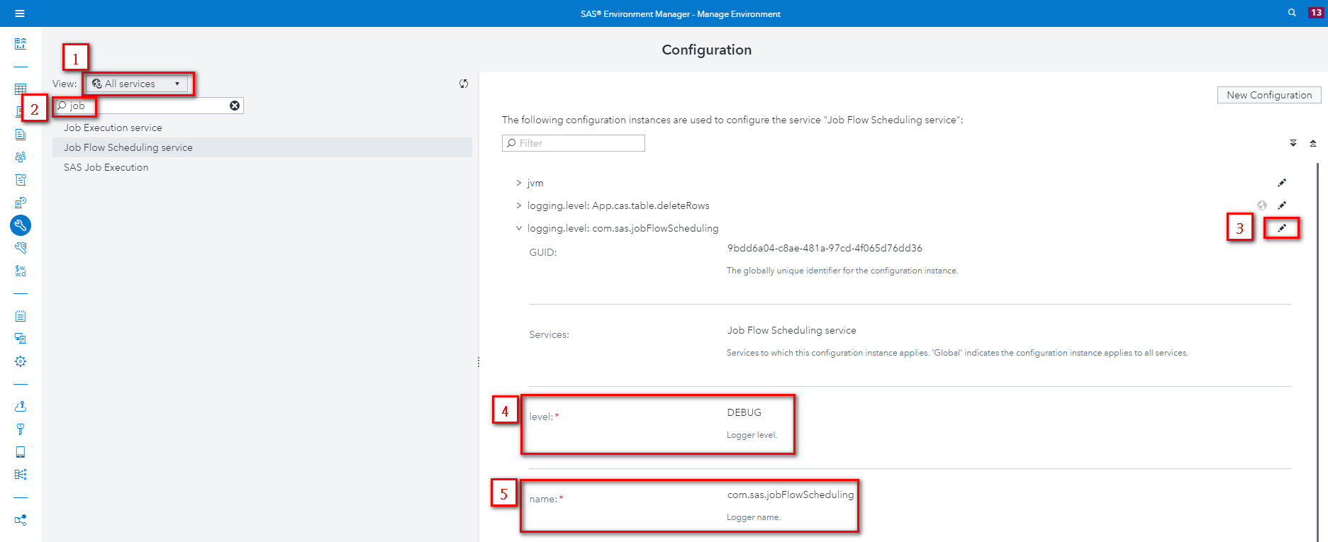

1: Select ‘All Services’

2: Search ‘job’

3: Choose Job Flow Scheduling service and click ‘Edit’

4: Edit level to ‘DEBUG’

5: Edit name to ‘com.sas.jobFlowScheduling’

Note: 如果找不到configuration, 點選 ‘New Configuration’新增configuration

6: 至micro01重啟sas-viya-jobflowscheduling-default

|  |
| --- |
| # systemctl restart sas-viya-jobflowscheduling-default |

**設定SAS Job Execution Service Log level by SAS Environment Manager**

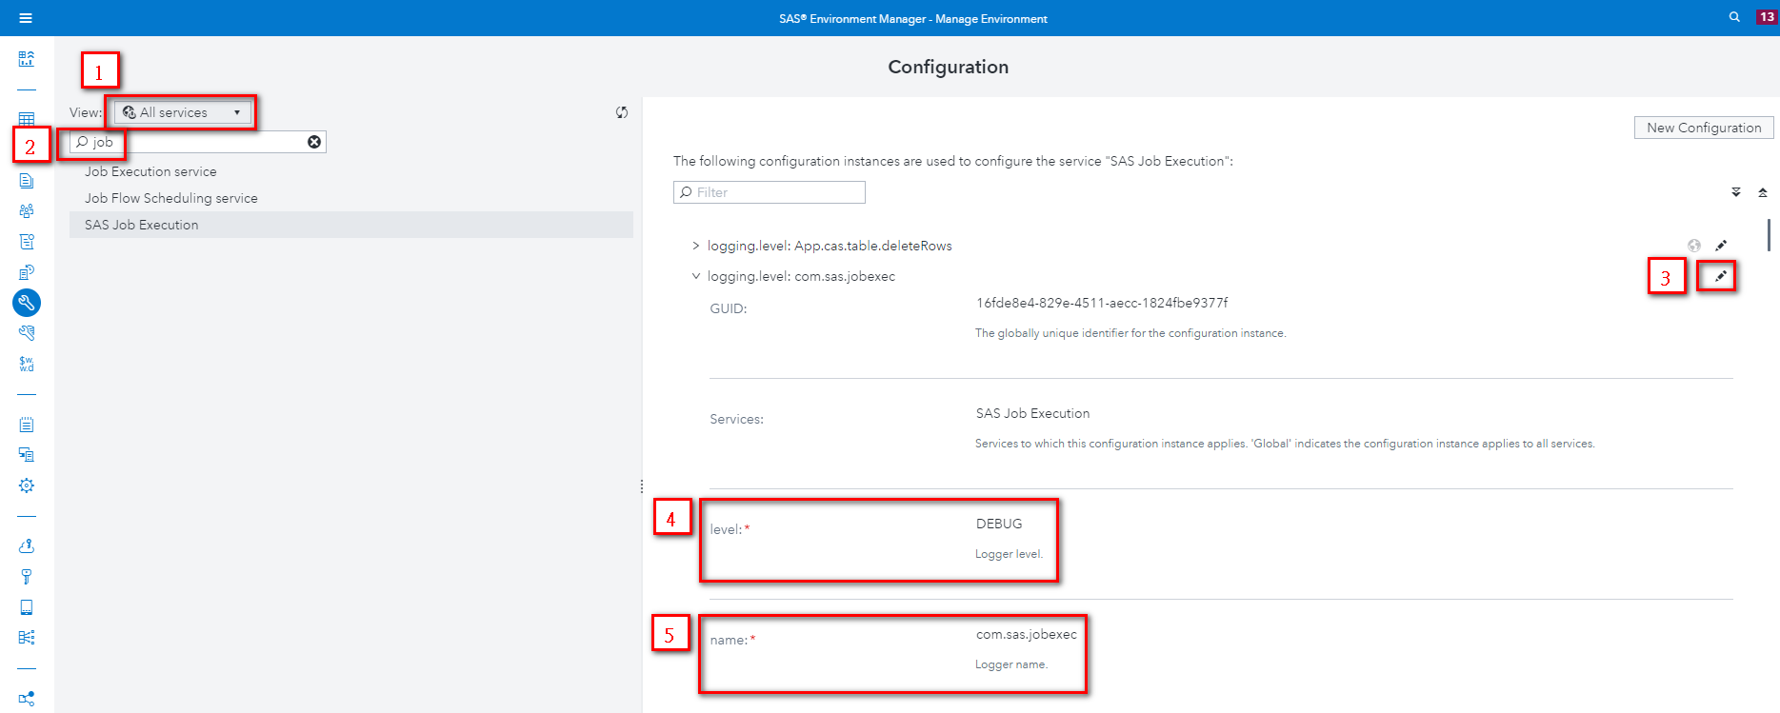

1: Select ‘All Services’

2: Search ‘job’

3: Choose SAS Job Execution and click ‘Edit’

4: Edit level to ‘DEBUG’

5: Edit name to ‘com.sas.jobexec’

Note: 如果找不到configuration, 點選 ‘New Configuration’新增configuration

6: 至micro01重啟sas-viya-jobexecapp-default

|  |
| --- |
| # systemctl restart sas-viya-jobexecapp-default |

**設定Schedule service Log Level by SAS Environment Manager**

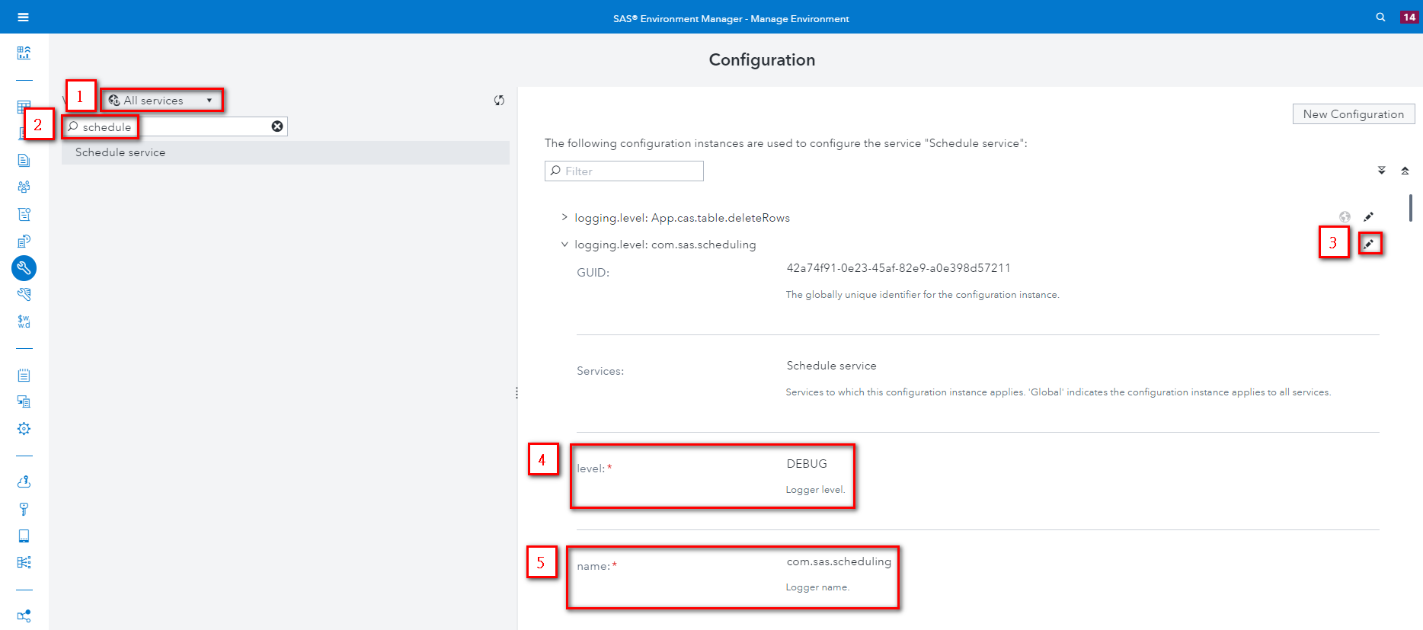

1: Select ‘All Services’

2: Search ‘schedule’

3: Choose Schedule service and click ‘Edit’

4: Edit level to ‘DEBUG’

5: Edit name to ‘com.sas.scheduling’

Note: 如果找不到configuration, 點選 ‘New Configuration’新增configuration

6: 至micro01重啟sas-viya-scheduler-default

|  |
| --- |
| # systemctl restart sas-viya-scheduler-default |

**設定Compute service Log Level by SAS Environment Manager**

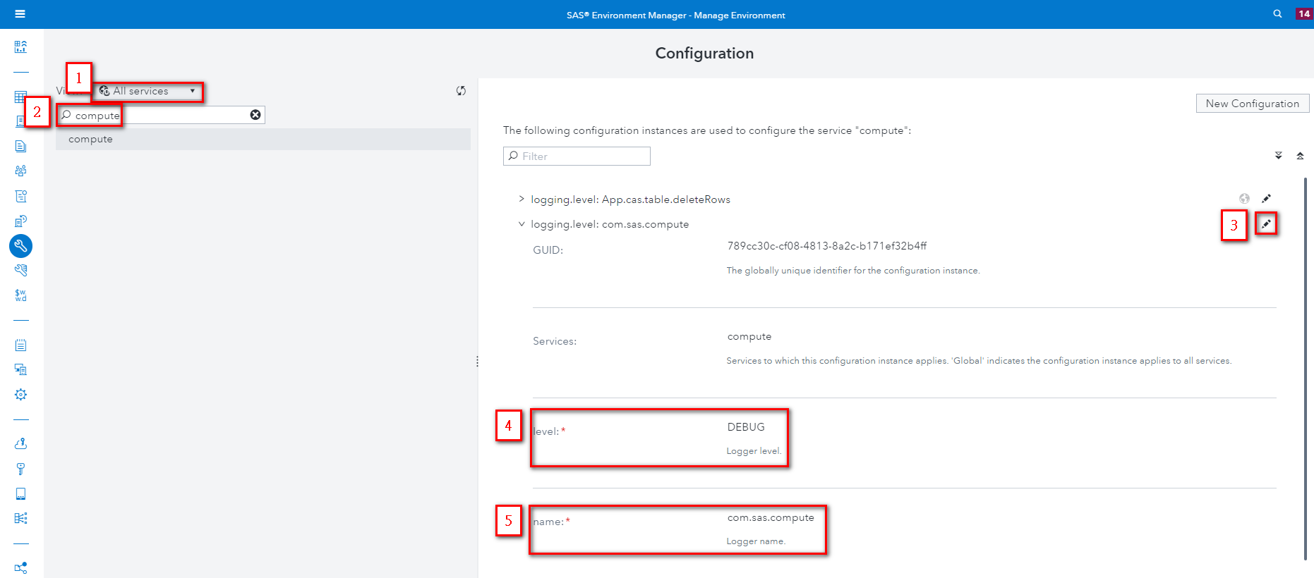

1: Select ‘All Services’

2: Search ‘compute’

3: Choose compute service and click ‘Edit’

4: Edit level to ‘DEBUG’

5: Edit name to ‘com.sas.compute’

Note: 如果找不到configuration, 點選 ‘New Configuration’新增configuration

6: 至micro01重啟sas-viya-compute-default

|  |
| --- |
| # systemctl restart sas-viya-compute-default |

## 確認SAS Viya Service狀態

點選左側”儀表板”並確認服務狀態, 綠燈表示正常啟用

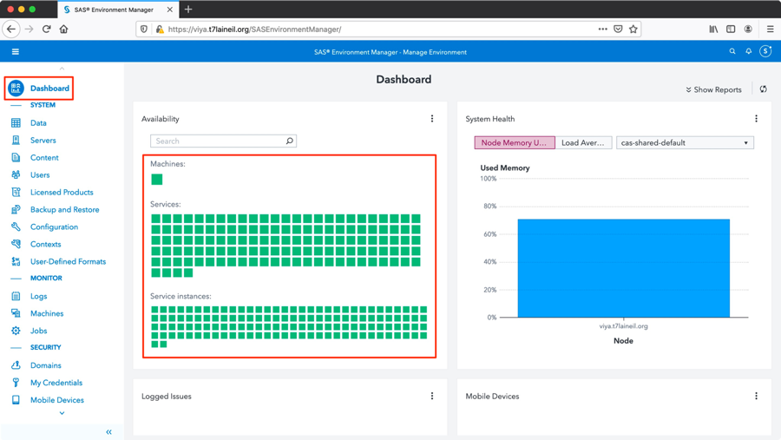

## 驗證SAS Viya版本

點選右上方”“, 點選”關於”

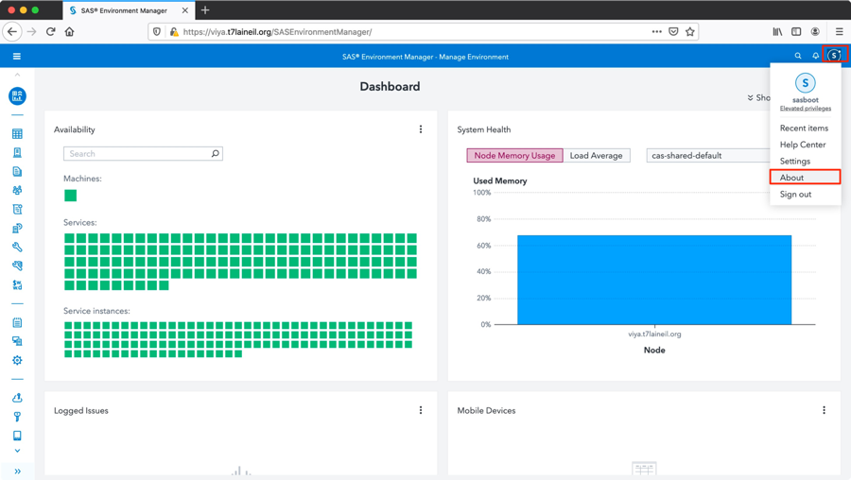

驗證為Viya3.5版本

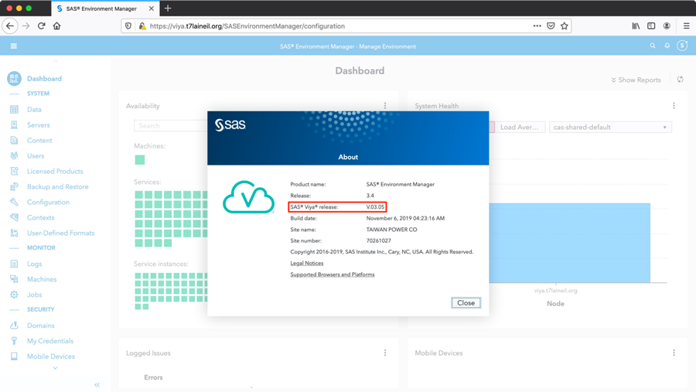

## 確認SAS Liciense Products

點選左側”授權產品”, 確認”產品”授權及”到期日期”

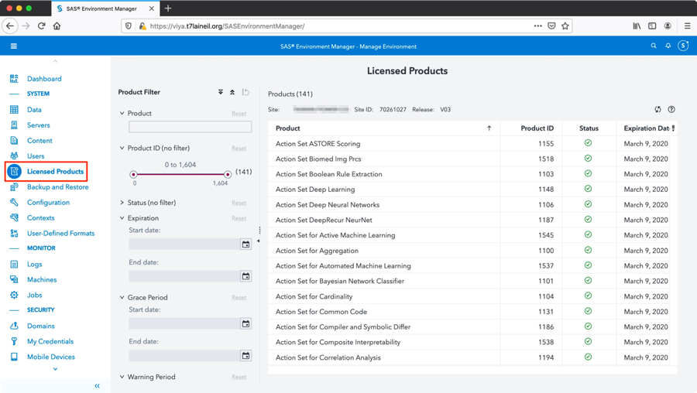

## 設定AD連線SAS Environment Manager

點選左側”組態”, 點選”Identities service”, 根據客戶環境的AD或LDAP修改設定,

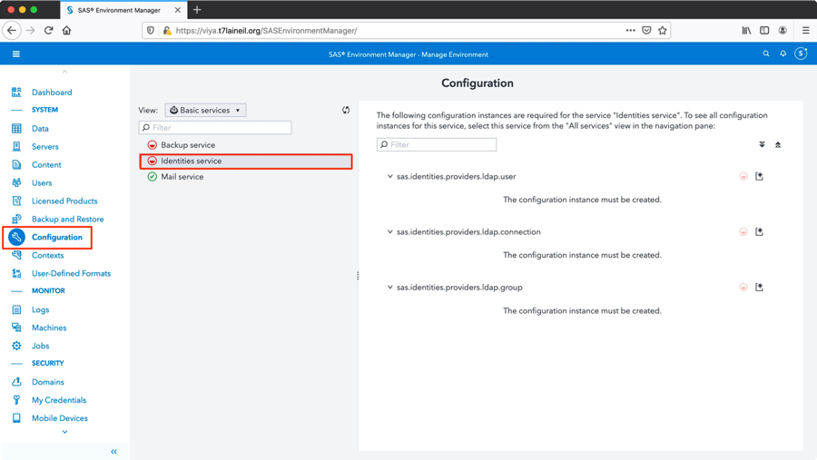

## 配置sas.identities.providers.ldap.connection

(AD主要 : host, password, port, userDN)

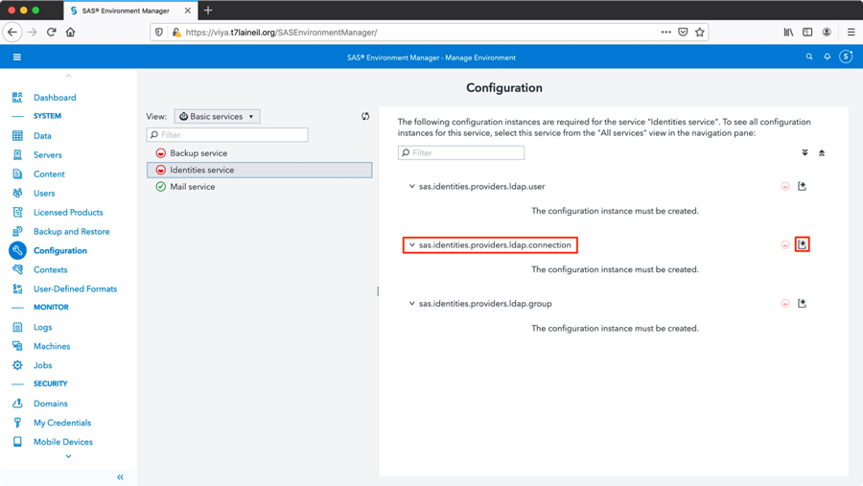

password為userDN的密碼, 此處範例為demopw

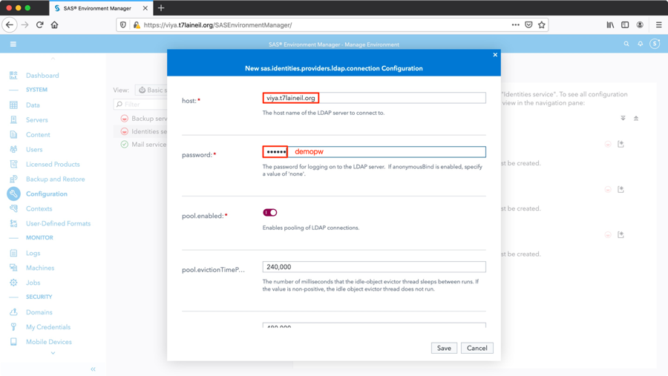

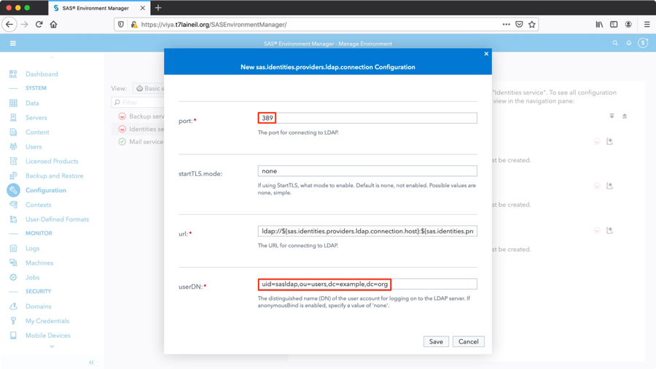

## 配置sas.identities.providers.ldap.group

(AD主要 : baseDN)

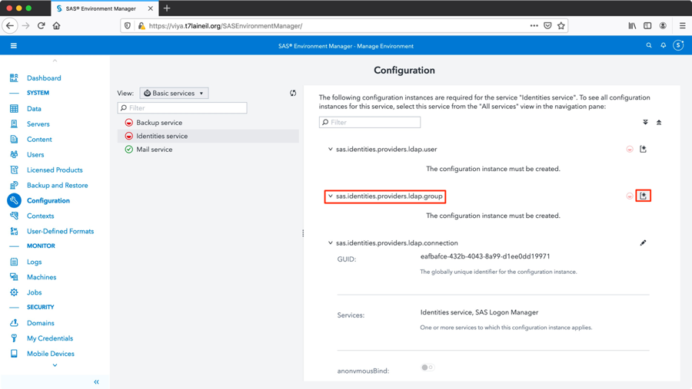

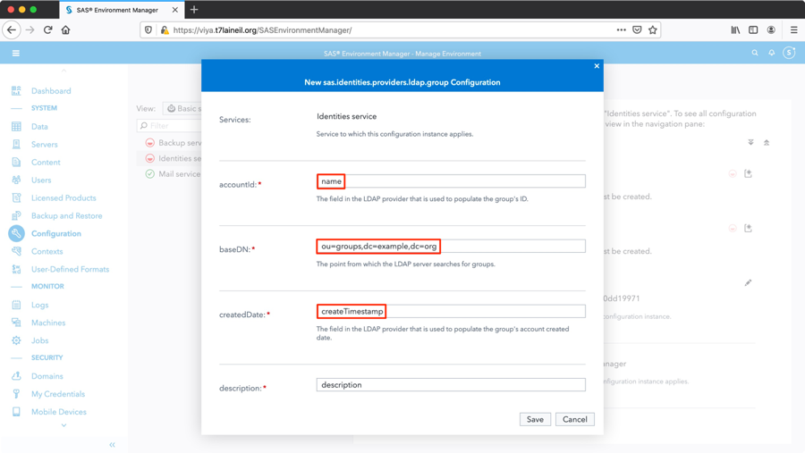

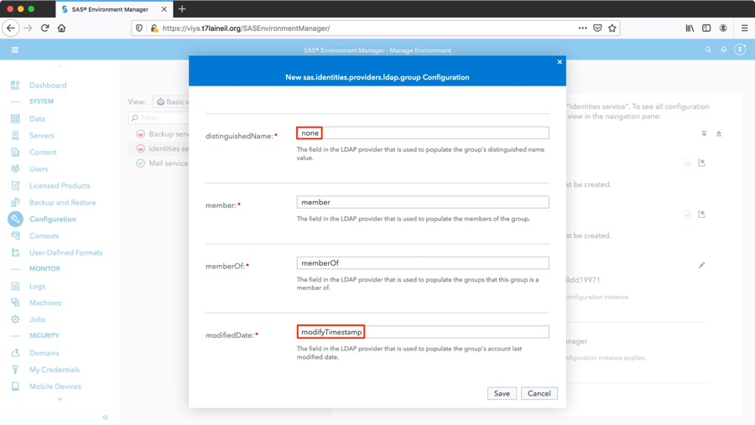

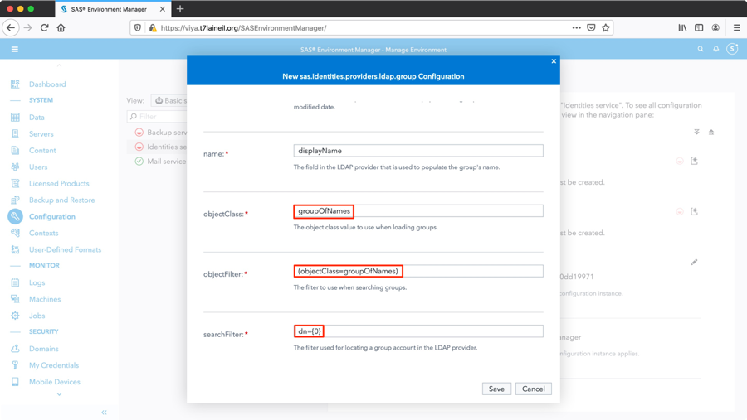

## 配置sas.identities.providers.ldap.user

(AD主要 : baseDN)

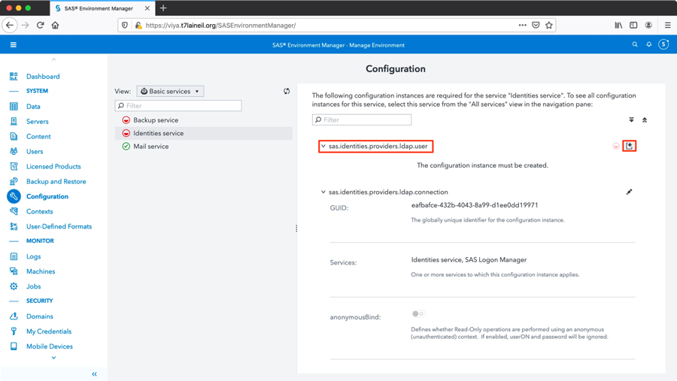

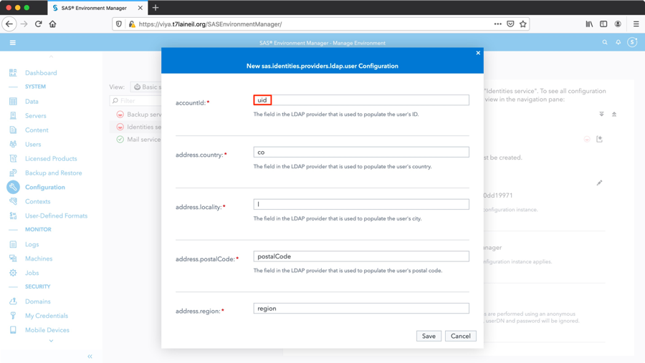

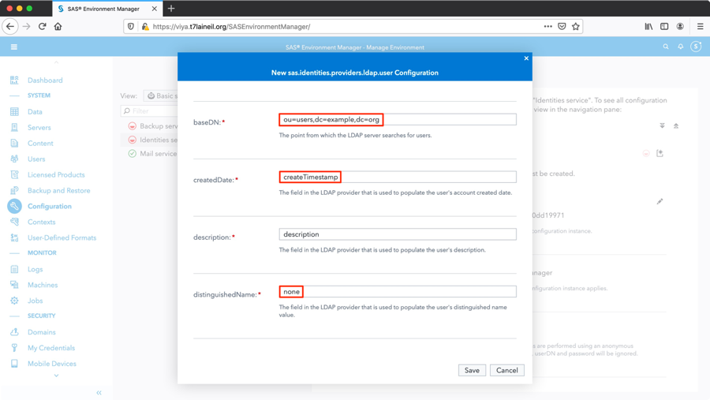

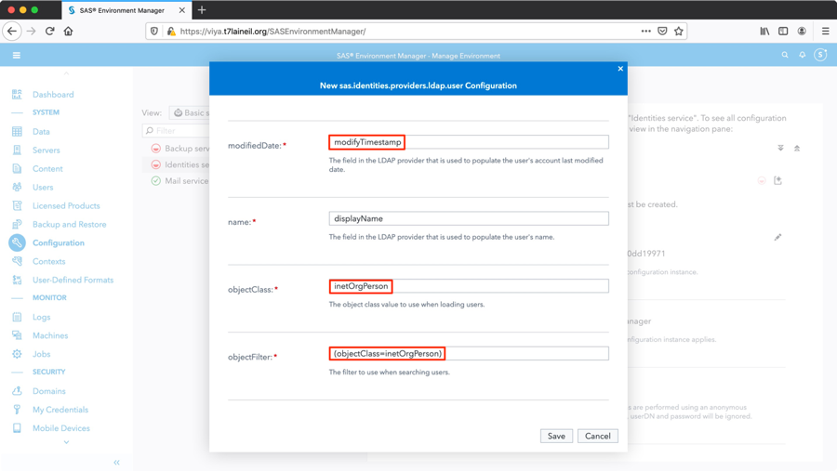

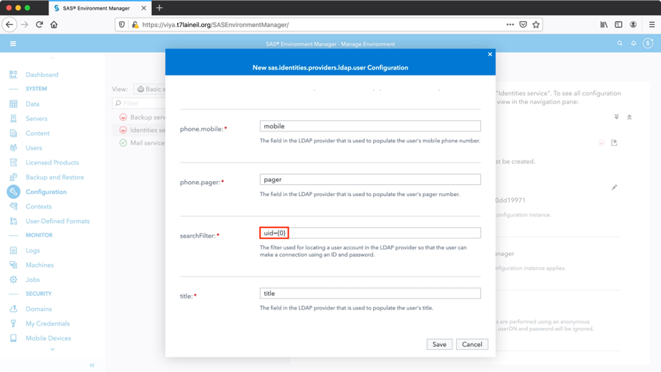

確認設定完成

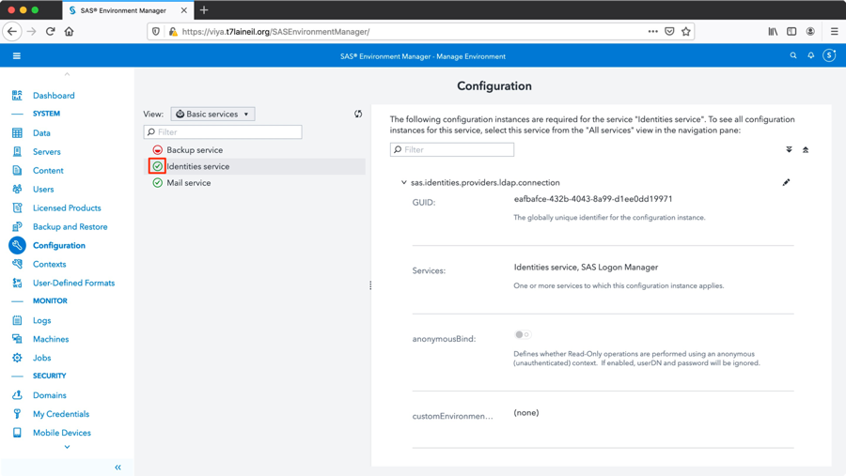

## 驗證AD連線SAS Environment Manager

登入micro service node, 重啟相關的SAS Viya Service

[Microservie01~Microservice03]

|  |
| --- |
| [root@micro01 ~]# systemctl restart sas-viya-identities-default  [root@micro01 ~]# systemctl restart sas-viya-saslogon-default |

重新整理url頁面,

驗證AD使用者-點選左側”使用者”, 點選下拉表單, 點選”使用者”

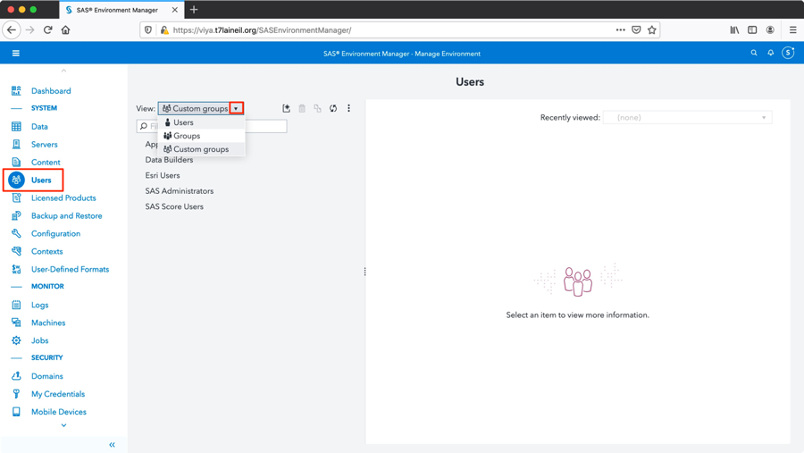

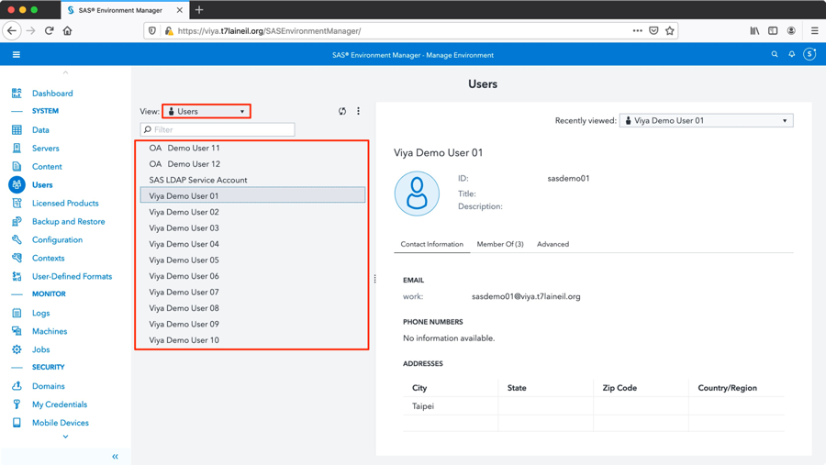

驗證AD群組-點選左側”使用者”, 點選下拉表單, 點選”群組”

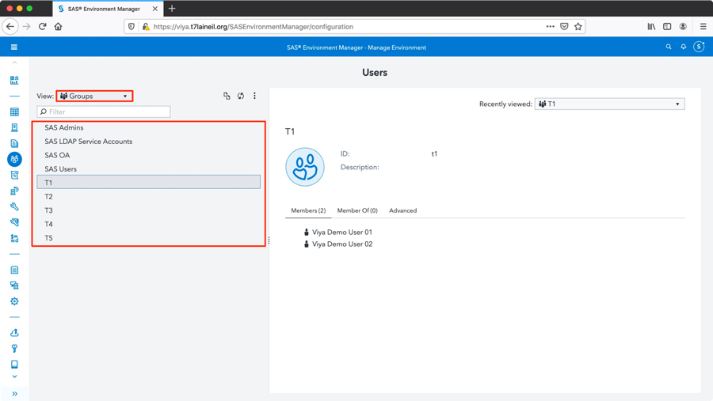

驗證AD帳號登入-此處使用帳號sasdemo02, 密碼為demopw

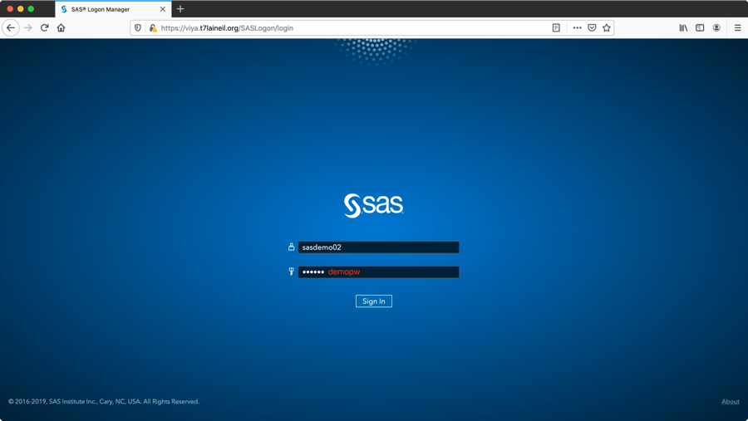

選擇主題設定或略過

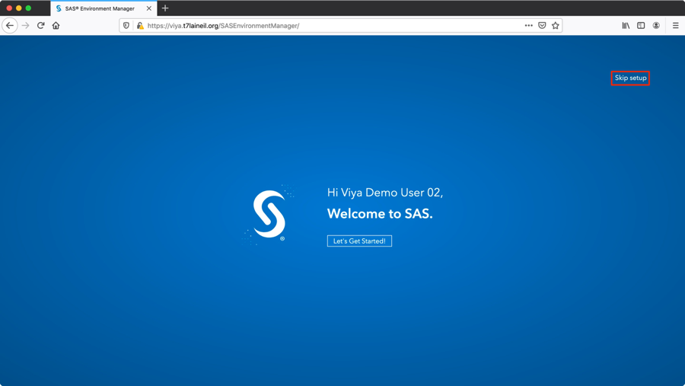

初次登入sasdemo02預設畫面

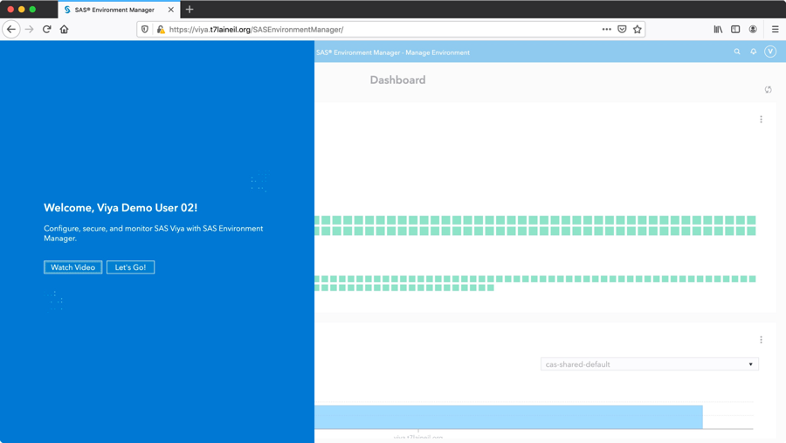

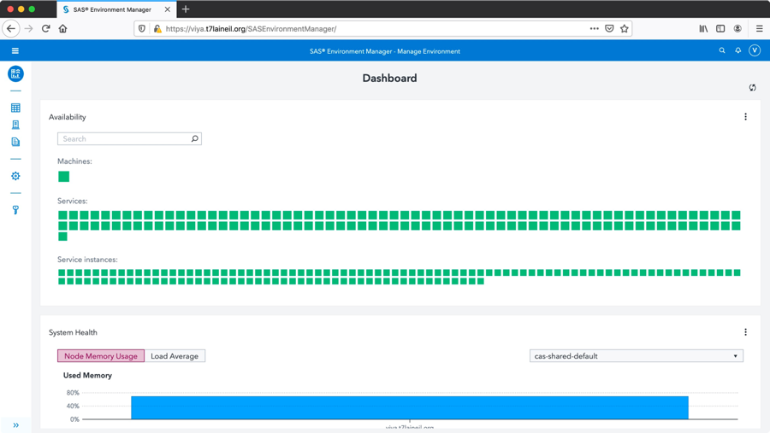

## 3.7.5 Linux加入AD網域

查詢AD網域(all)

[all_nodes]安裝Linux加入AD網域所需的相關套件

|  |
| --- |
| # yum install krb5-workstation krb5-libs realmd sssd samba-common adcli |

查詢所有網域

|  |
| --- |
| # realm list |

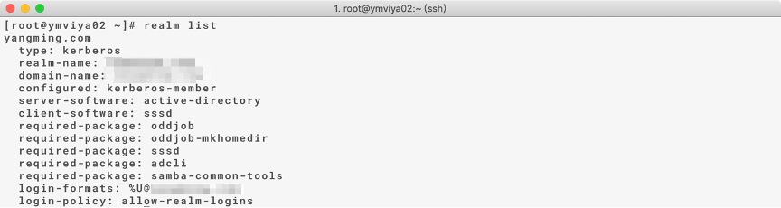

查詢特定網域

|  |
| --- |
| # realm discover *[ADserver_FQDN]* |

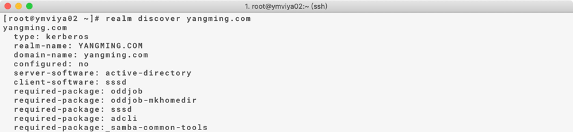

加入AD網域(all)

將Linux加入網域

|  |
| --- |
| #realm join *[ADserver_FQDN]* --user *[AD_acconunt]* |



驗證AD帳號加入

|  |
| --- |
| # id *[AD_user@domain]* |

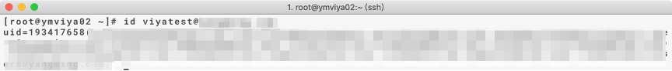

設定sssd(all)

|  |
| --- |
| # vim /etc/sssd/sssd.conf  use_fully_qualified_names = False  fallback_homedir = /home/%u |

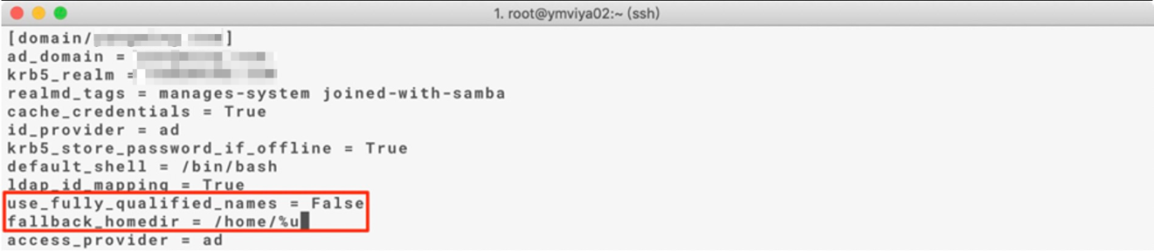

|  |
| --- |
| # systemctl restart sssd |

驗證AD帳號名

|  |
| --- |
| # id *[AD_user]* |



Enable dir creation for AD user

**設定SAS Launcher Server & SAS Copmute Server**

設定 Laurcher Server & Compute Server Configuration [control01]

|  |
| --- |
| [root@control01 ~]# . /opt/sas/viya/config/consul.conf  [root@control01 ~]# /opt/sas/viya/home/bin/sas-bootstrap-config –token-file /opt/sas/viya/config/etc/SASSecurityCertificateFramework/tokens/consul/default/client.token kv write config/launcher-server/global/environment/SASMAKEHOMEDIR 1 |

重啟服務以生效[Microservie01~Microservice03]

|  |
| --- |
| [root@control01 ~]# ansible microservice -m shell -a “systemctl restart sas-viya-runlauncher-default” |

**設定SAS Object Spawner**

設定 Object Spawner Server Configuration [Microservie01~Microservice03]

|  |
| --- |
| [root@micro01 ~]# . /opt/sas/viya/config/consul.conf  [root@micro01 ~]# vi /opt/sas/viya/config/etc/spawner/default/spawner_usermods.sh  新增以下內容到檔案中  spawner_options=”${spawner_options//-ssl*/}”  export SASMAKEHOMEDIR=1 |

複製檔案到其他主機[Microservie01~Microservice03]

|  |
| --- |
| [root@micro01 ~]# scp /opt/sas/viya/config/etc/spawner/default/spawner_usermods.sh micro02: /opt/sas/viya/config/etc/spawner/default/spawner_usermods.sh  [root@micro01 ~]# scp /opt/sas/viya/config/etc/spawner/default/spawner_usermods.sh micro03: /opt/sas/viya/config/etc/spawner/default/spawner_usermods.sh |

重啟服務以生效[Microservie01~Microservice03]

|  |
| --- |
| [root@control01 ~]# ansible microservice -m shell -a “systemctl restart sas-viya-spawner-default” |

**設定SAS Cloud Analytic Services**

設定 Cloud Analytic Services [control01, control02]

|  |
| --- |
| [root@control01 ~]# vi /opt/sas/viya/config/etc/cas/default/casconfig_usermods.lua  新增以下內容到檔案中  env.CASMAKEHOMEDIR='ALL'  env.CASHOMEDIRLOC=’/home’  env.CASHOMEDIRPERMS=’0700’ |

重啟服務以生效[control01)

|  |
| --- |
| [root@control01 ~]# systemctl restart sas-viya-cascontroller-default |

## 配置SAS Environment Manager管理者

以下範例為將sasdemo01及sasdemo02帳號加入SASEnvironmentManager管理者群組,

包含Application Administrators及SAS Administrators,

使用sasboot帳號登入SASEnvironmentManager



## 配置Application Administrators

進入管理環境設定Application Administrators

點選左側”使用者”=>“自訂群組”=> “Application Administrators”

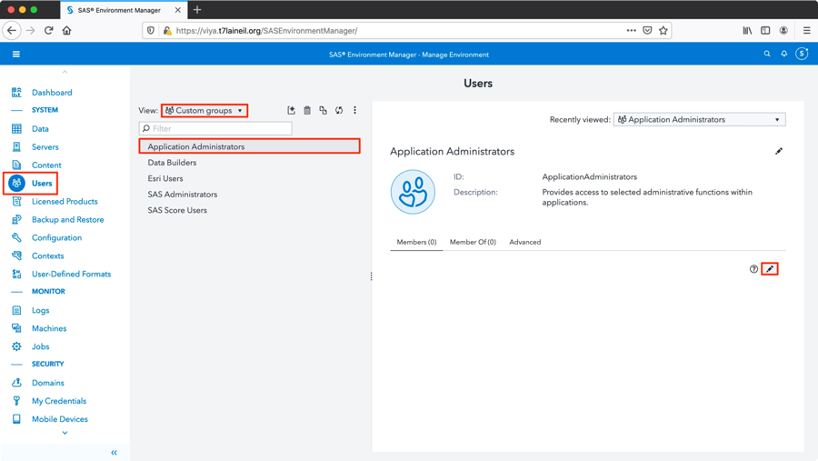

將欲加入之使用者拉到”選取的識別身份”, 點選”確定”

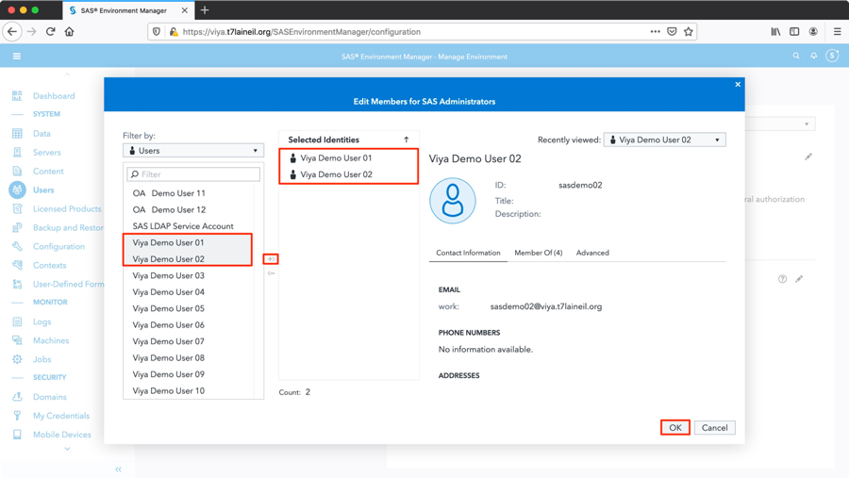

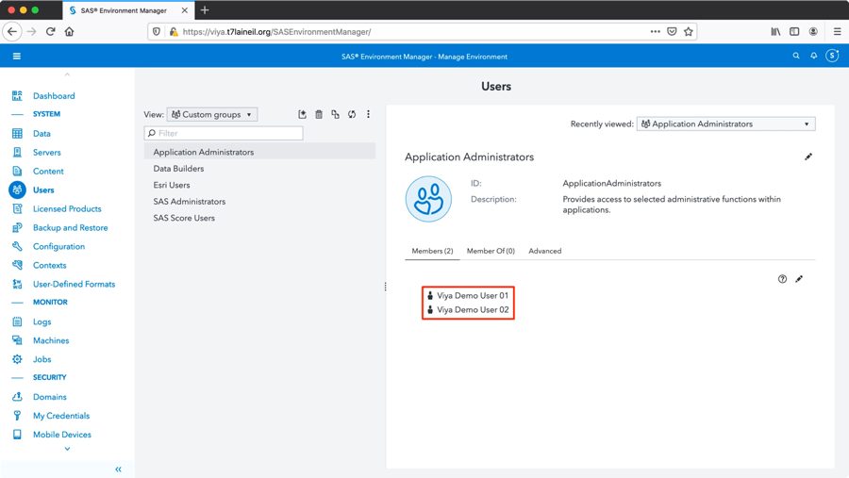

## 配置SAS Administrators

點選” SAS Administrators”

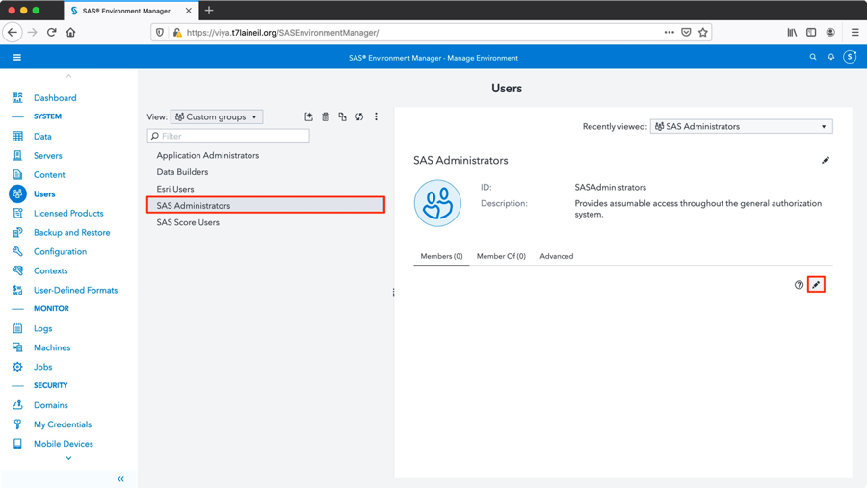

將欲加入之使用者拉到”選取的識別身份, 點選”確定”

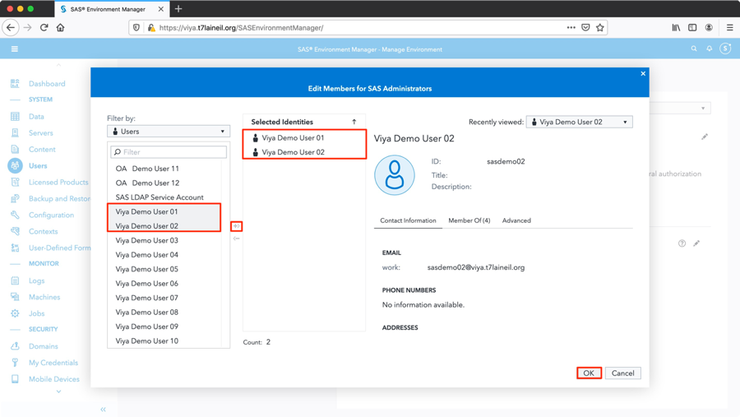

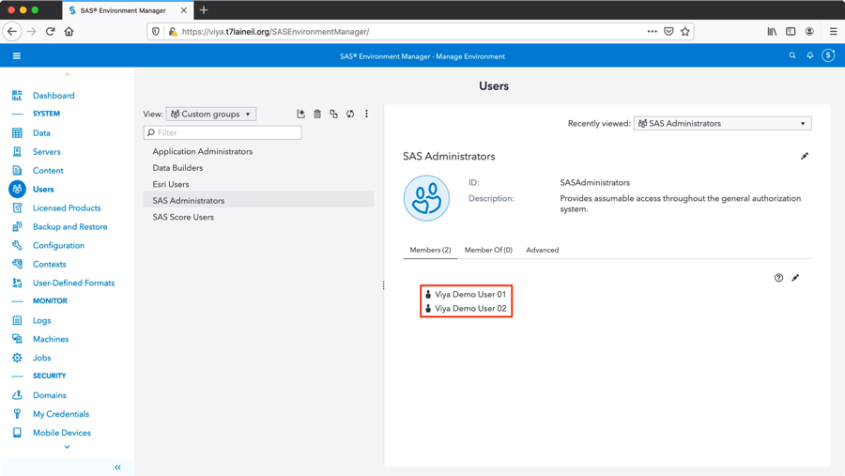

## 驗證administrators配置

驗證sasdemo02成為SASEnvironmentManager管理者,

使用sasdemo02登入, 密碼為demopw



出現可代入群組畫面



登入畫面變為與sasboot相同的管理者畫面

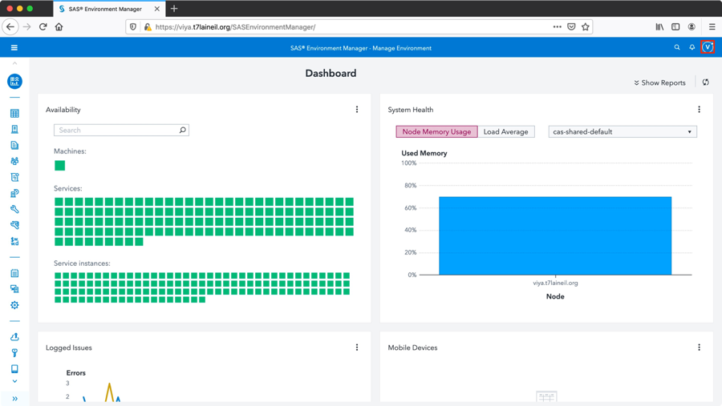

## SAS Environment Manager備份功能

此章節指的備份為SAS Environment Manager的meta data

## 配置SAS EnvironmentManager備份路徑(control01)

規劃備份所在目錄及設定權限，位置需為shared location

|  |
| --- |
| [root@control01 ~]# mkdir /SAS/viyabackup  [root@control01 ~]# chown sas:sas /SAS/viyabackup |

使用SASEnvironmentManager管理者登入, 此範例使用sasboot,

點選左側”組態”, 點選”Backup service”

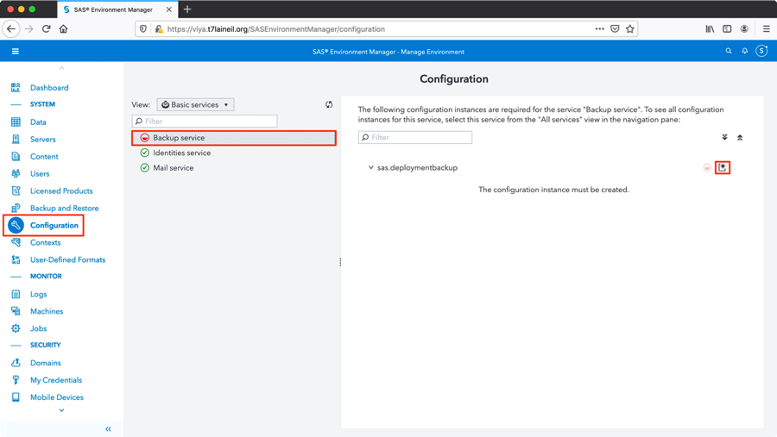

設定Backup service配置, 設定shareVault path, 並點選確定

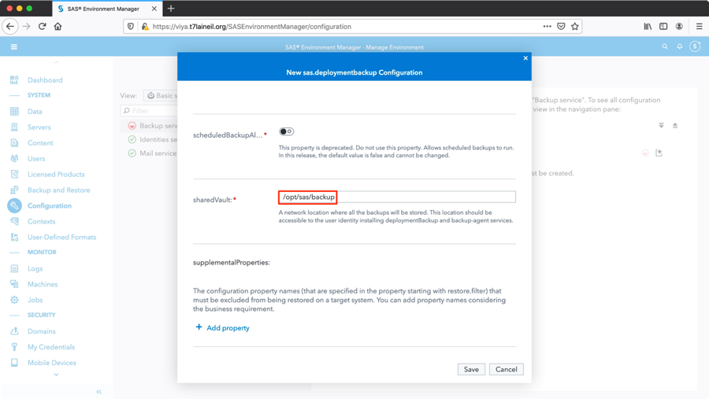

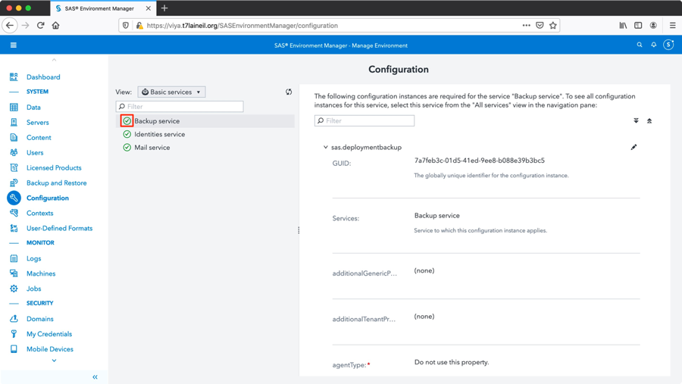

## 測試SAS EnvironmentManager備份

點選左側”備份和還原”

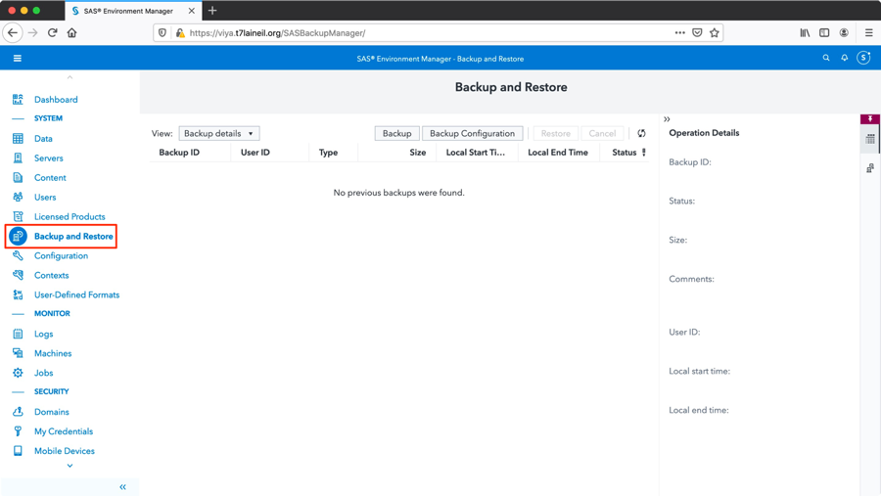

點選”備份”-Default

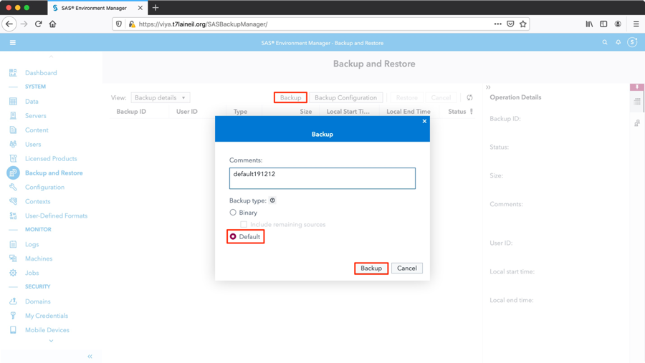



點選”備份”-Binary

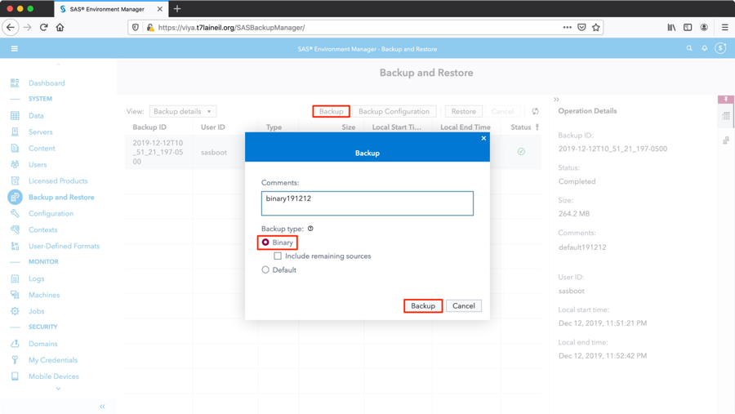

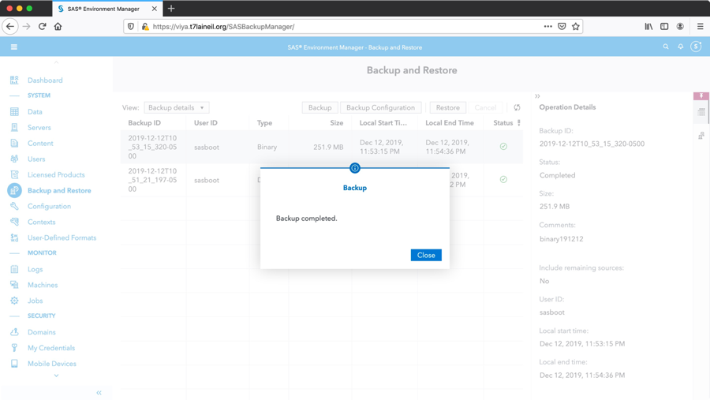

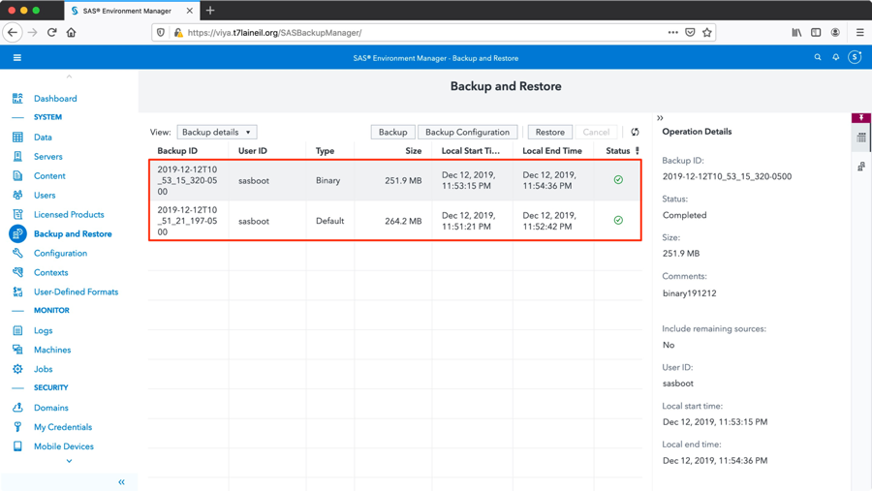

驗證Backup service

|  |
| --- |
| [root@micro01~]# ls -l /SAS/viyabackup/  [root@micro01~]# du -sh /SAS/viyabackup/ |

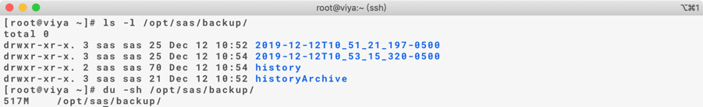

## 測試連線Oracle DB

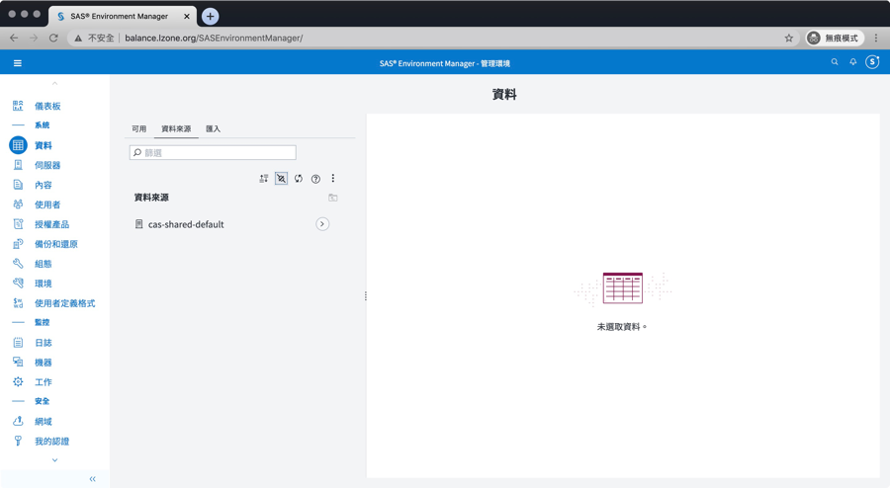

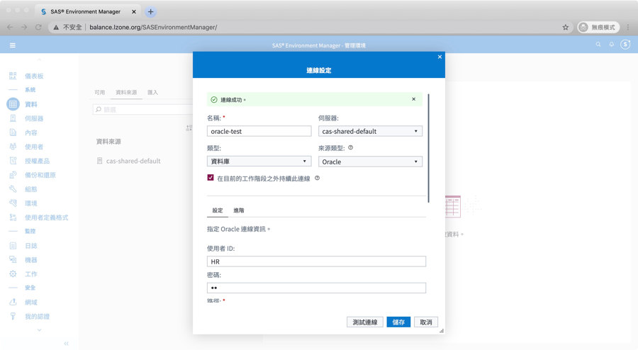

## 測試SAS StudioV功能

調整SAS StudioV服務記憶體大小

1. 設定SAS Studio Viya Initial Heap Size and Maximum Heap size :

Configuration -> select All services > SAS Studio Viya -> New Configuration -> select jvm

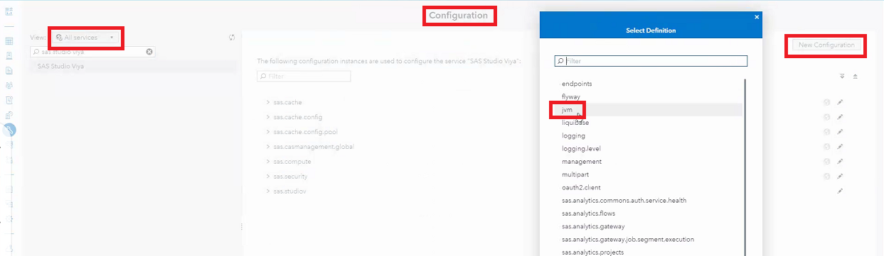

Add property -> Name : java_option_xms, Value=-Xms4096m

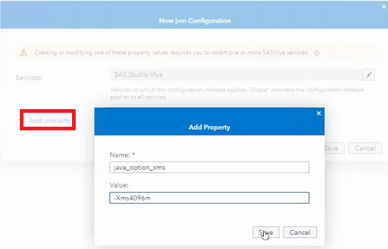

Add property -> Name : java_option_xmx, Value=-Xmx4096m

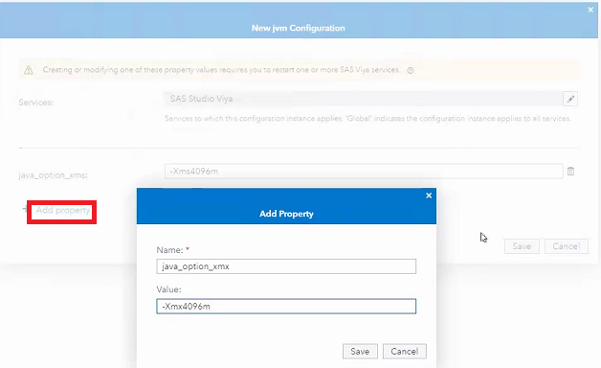

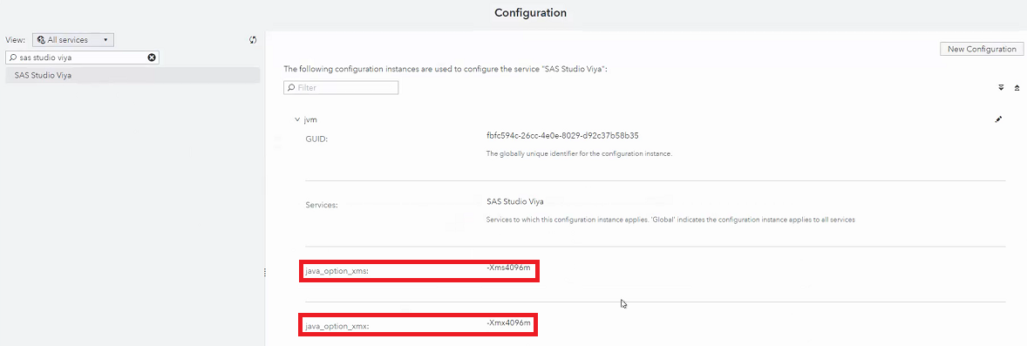

1. 設定SAS Compute service Maximum Heap size :

Configuration -> select All services > Compute -> New Configuration -> select jvm

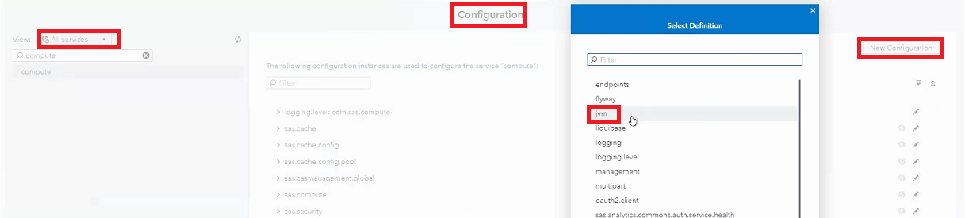

Add property -> Name : java_option_xmx, Value=-Xmx4096m

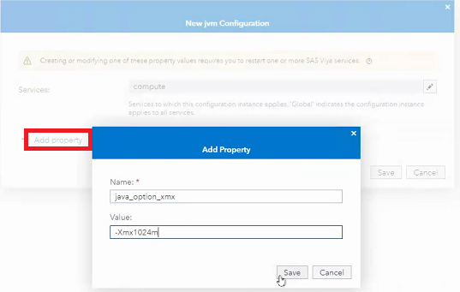

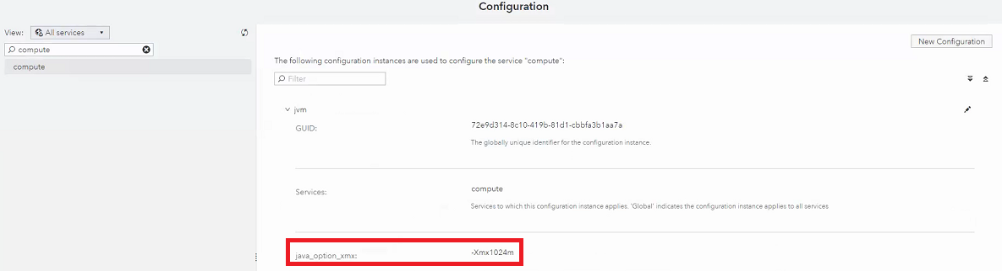

1. 登入micro service node，重啟sas-viya-studiov-default及sas-viya-compute-default服務

[microservice01- microservice03]

[root@micro01~]# systemctl restart sas-viya-studiov-default

[root@micro01~]# systemctl restart sas-viya-compute-default

/var/log/sas/viya/studiov/default/sas-studiov-_yyyy-MM-dd_hh-mm-ss.log可檢查

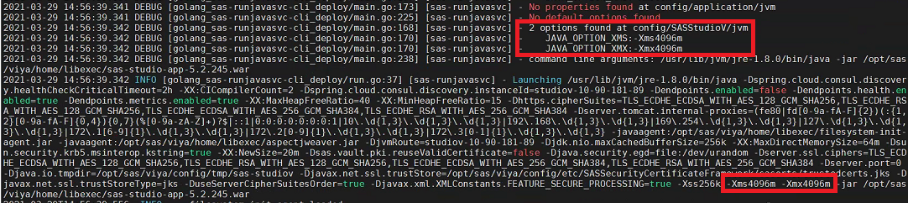

/var/log/sas/viya/compute/default/sas-compute-_yyyy-MM-dd_hh-mm-ss.log可檢查

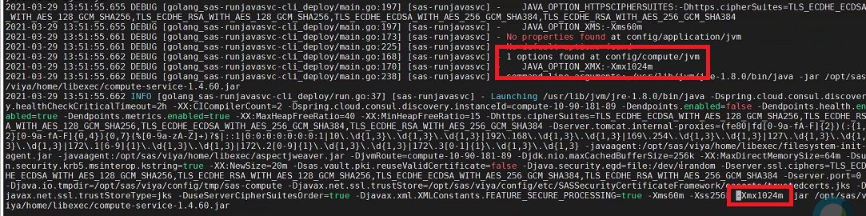

SAS StudioV需使用AD或LDAP帳號登入, 且需整合Linux

需先完成 3.7.5 Linux加入AD網域

開啟瀏覽器, 建議使用firefox或chrome,

此處使用firefox為例, 輸入下方url,

[http://*[loadbalance_url]*/SASStudioV](http://[loadbalance_url]/SASStudioV),

使用AD帳號登入, 此範例使用sasdemo03, 密碼為demopw

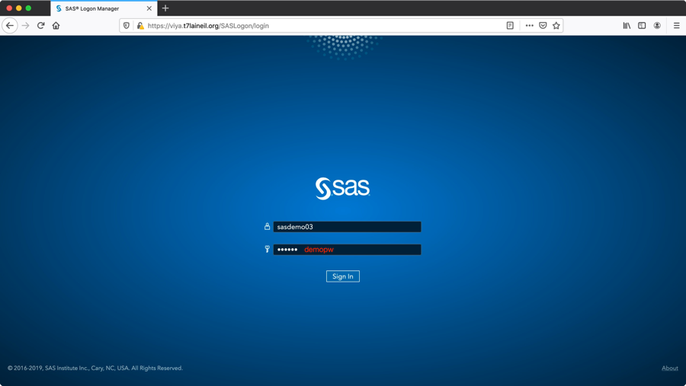

選擇主題設定或略過

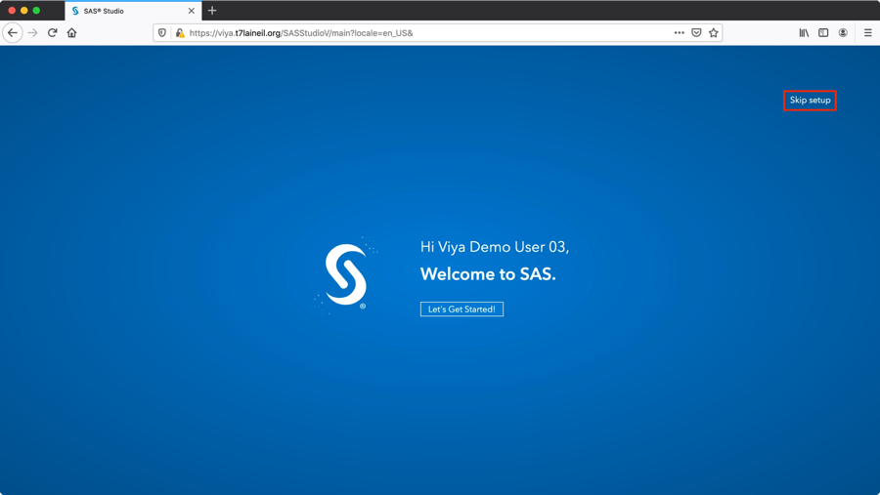

SASStudioV預設登入畫面



點選左側”程式碼片段”, 點選”SAS Viya Cloud Analytic Services”, 點選”建立cas連線”

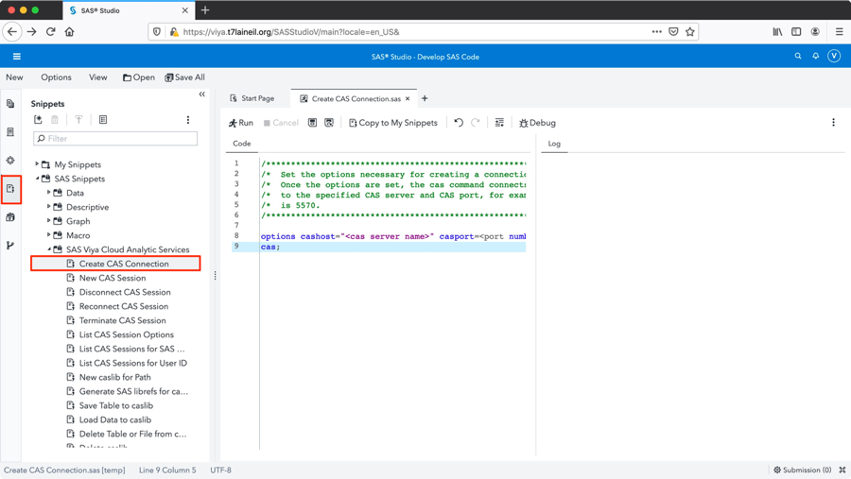

修改cashost為主機位置及port(預設為5570)並點選上方, 並確認執行成功

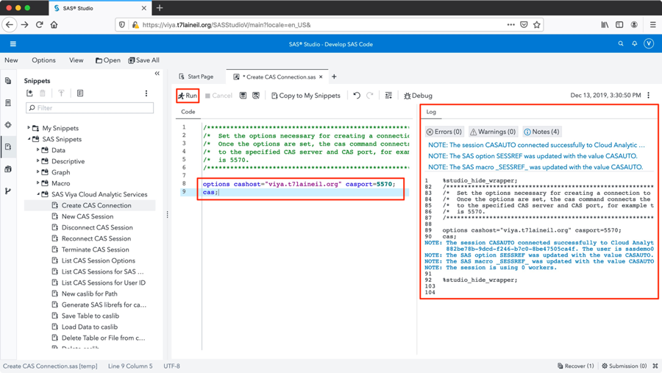

# **增加CAS Server**

為了不同用途的使用者，可以使用切割CAS Server的方式去達到限制worker或是只使用GPU worker。此動作可基於原本的安裝跑Playbook即可。建議在增加CAS Server之前先進行備份。

## Pre-installation

若是新增的機器，在安裝前須先確認系統與環境是否符合需求，此文件之準備安裝任務需在新增機器完成。開始安裝任務需確認2.4 Pre-install Check 至 2.7 SAS StudioV workerspace已完成。

**OpenLDAP Client(若使用LDAP驗證才需要)**

將要新增的Server加入LDAP設定，並且重新執行一次setup，執行結束後確認新的Server有加入LDAP User即代表成功

## Copy and Modify file

**Inventory.ini**

複製原先的inventory.ini file 為 inventory_server02.ini

|  |
| --- |
| [root@control01 ~]# cp inventory.ini inventory_server02.ini |

修改inventory_server02.ini file (增加server以及microservice server定義)

|  |
| --- |
| [root@control01 ~]# vi inventory_server02.ini  ## 在原先定義Server下面加上新的server (不要刪除舊的)  gpu-control01 ansible_host=ip-10-249-6-98.ec2.internal ansible_ssh_private_key_file=~/.ssh/id_rsa  gpu-control02 ansible_host=ip-10-249-7-190.ec2.internal ansible_ssh_private_key_file=~/.ssh/id_rsa  gpu-worker01 ansible_host=ip-10-249-6-233.ec2.internal ansible_ssh_private_key_file=~/.ssh/id_rsa  gpu-worker02 ansible_host=ip-10-249-7-65.ec2.internal ansible_ssh_private_key_file=~/.ssh/id_rsa  ## 將所有中括號定義下面的 server刪除(除了 [consul]、[httpproxy]以及[sas_all:children])  ## 但是皆保留群組定義，範例如下  [AdminServices]  ~~micro01~~  ~~micro02~~  ~~micro03~~  # The AdvancedAnalytics host group contains services that provide advanced analytics features.  [AdvancedAnalytics]  ~~micro01~~  ~~micro02~~  ~~micro03~~  …..  # The httpproxy host group contains HTTP Proxy Server.  [httpproxy]  micro01  micro02  micro03  …. |

修改inventory_server02.ini file (加入新的cas server定義)

|  |
| --- |
| [root@control01 ~]# vi inventory_server02.ini  ## 加入CAS Cluster (僅新增部分)，範例如下  [sas_casserver_primary]  gpu-control01  [sas_casserver_secondary]  gpu-control02  [sas_casserver_worker]  gpu-worker01  gpu-worker02 |

**vars.yml**

複製原先的vars.yml file 為 vars_server02.yml

|  |
| --- |
| [root@control01 ~]# cp vars. yml vars_server02. yml |

修改vars_server02.yml file

|  |
| --- |
| [root@control01 ~]# vi vars_server02.yml  ## 在CAS Configuration 下增加 casenv_instance  ############################################################################  ## CAS Configuration  ############################################################################  # The user that the CAS process will run under  # This user must be a member of the "sas" group  casenv_user: cas  casenv_instance: gpu  *設定值不可包含特殊符號(e.g. ‘-‘,’*’…)  *若取名為”gpu”，新的CAS Server 名稱為 “ cas-shared-gpu ” |

## Run ansible

|  |
| --- |
| [root@control01 ~]# ansible-playbook -i inventory_server02.ini site.yml -e "@vars_server02.yml" |

## Post-installation

針對新增的CAS Server 進行安裝後任務，但是因為Microservice部分沿用原本的deployment，所以只進行與CAS相關的部分即可

1. 設定Disable Viya Auto Start (再執行一次2.9)
2. Post Configuration(3.1) 中非Microservice部分(若為contorller上但使用ansible指令，需再執行一次)
3. 確認Multiple Server安裝成功，使用Administrator 登入SAS環境(<http://[loadbalancer]/SASEnvironmentManager/>)，確認有兩個CAS Server，並且驗證Service狀態。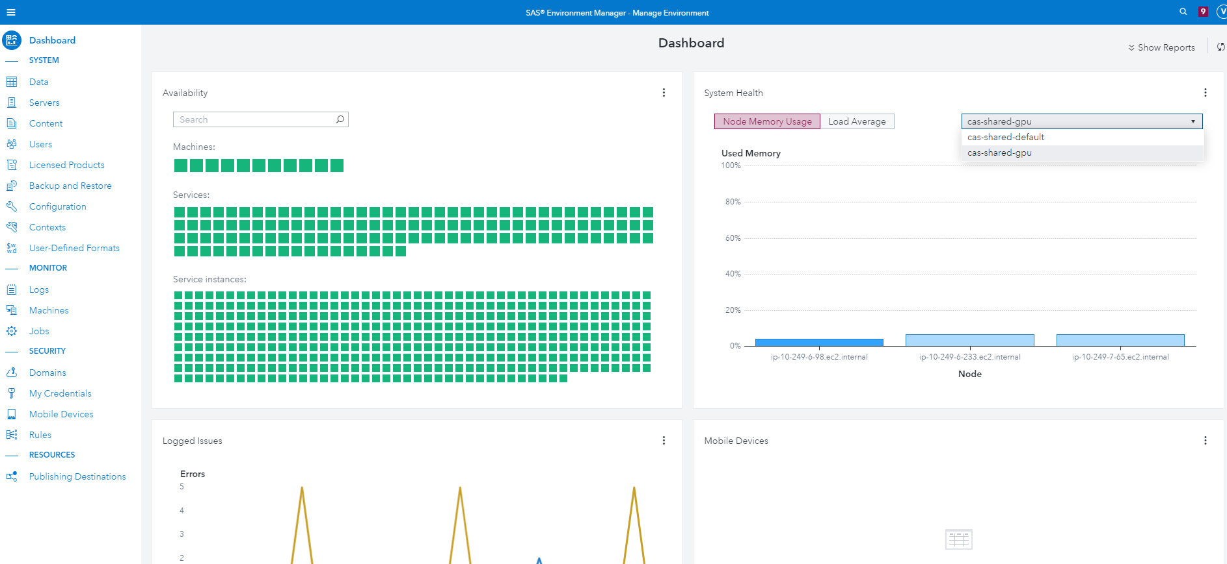
4. 使用程式碼確認兩個CAS Server都可連線且使用不同的Worker

前往SASStudioV，在程式碼區塊輸入以下程式，且根據不同Server輸入不同螢光處資訊。

|  |
| --- |
| options cashost=("[primary_controller]","[backup_controller]") casport=[casport];  cas test_default;  caslib _ALL_ assign;  data public.cars;  set sashelp.cars;  run;  proc cas;  table.tabledetails caslib="public" name="CARS" level="node";  run;  cas test_default terminate; |

輸出範例如下，輸入不同資訊會得到不同的Node，證明運行在不同的CAS Server

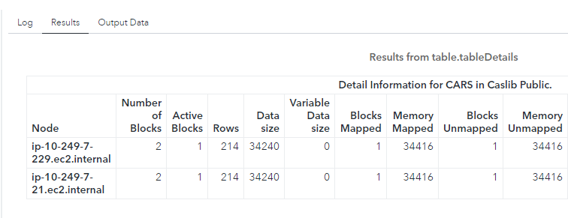

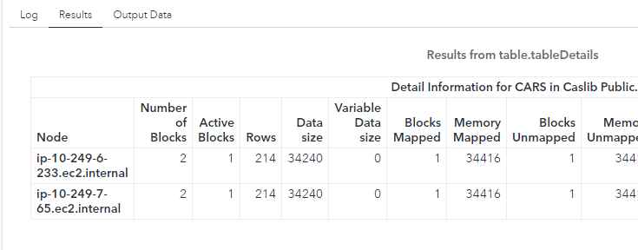

# **Viya系統監控**

除了Viya本身的服務監控機制外，也客製script去做更細節的監控

Log會放置於/CREPOS/Logs

## Monitor Script

Monitor Script放置於/CREPOS/monitor，script如下

|  |  |  |  |
| --- | --- | --- | --- |
| Script名稱 | Script功能 | 排程Server | 排程時間 |
| info.cfg | 紀錄連線資訊 | None | None |
| ping_backup.sh | 檢查backup controller是否正常運作 | Controller01 | 10mins一次 |
| clear_idle_session.sh | 刪除掉idle session(default為超過24h的session) | Controller02 | 一天一次(00:30) |
| check_controller_status.sh | 確認primary controller是否正常運作或者已切換至backup controller | Controller02 | 含在run_monitor排程中 |
| check_cas_process.sh | 確認cas worker與controller連線的process正常運作 | Controller02 | 含在run_monitor排程中 |
| service_monitor | 確認各server的viya service皆正常運作 | Controller02 | 含在run_monitor排程中 |
| run_monitor.sh | 含括check_controller_status, check_cas_process, service_monitor | Controller02 | 10mins一次 |
| Check_job_status.sh | 檢查是否有因backup controller fail而導致的job | Controller01 | 10mins一次 |

切換至p_viyaadmin

|  |
| --- |
| #su - p_viyaadmin |

查看crontab排程

|  |
| --- |
| #crontab -ls |

編輯crontab排程

|  |
| --- |
| #crontab -e |

## 5.2 Auto Backup and Restore CAS data

**Auto backup架構**

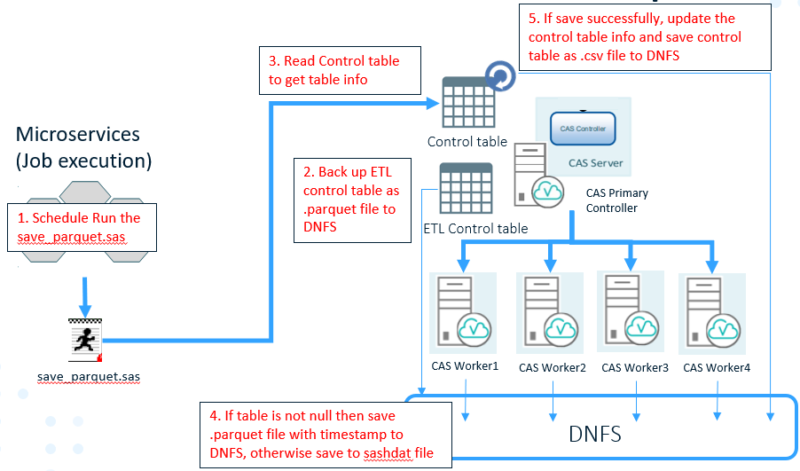

**Auto restore架構**

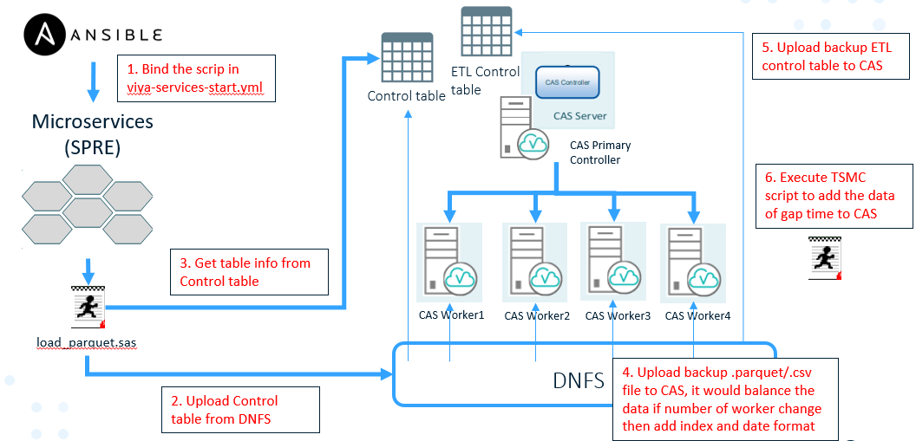

Auto backup and restore cas data的Script放置於/CREPOS/auto_upload_bk，script如下

|  |  |  |  |
| --- | --- | --- | --- |
| Script名稱 | Script功能 | 排程Server | 排程時間 |
| .authinfo | 紀錄連線資訊 | None | None |
| create_control.sas | 初次建立control_table使用 | None | None |
| get_token.sh | Renew token使用 | None | None |
| load_parquet.sas  load_table.sh | 該script會包進service重啟的playbook, CAS重啟時，自動upload .parquet file to CAS | None，透過Micro01~Micro03的任一台的  SPRE service執行 | None |
| save_parquet.sas | 自動backup CAS data as .parquet to /SAS/databackup | Micro01~Micro03的任一台的  SAS Job Scheduler Service | 每天05:00 |

由於load_parquet.sas檔會需要讀取authinfo獲得連線資訊，所以做下列設定

1. 於3台microservice server上的home目錄下面添加softlink

|  |
| --- |
| #ansible microservice -m shell -a ‘ln -s /CREPOS/auto_upload_bk /home/p_viyaadmin/auto_upload_bk’ |

1. 於3台microservice server上的home目錄下面添加.authinfo檔案並輸入連線資訊，檔案權限設定為600

|  |
| --- |
| # vi /CREPOS/.authinfo |

#######################################

host [cas primary server] user p_viyaadmin password [密碼]

##########################################

複製.authinfo至/home/p_viyaadmin底下

|  |
| --- |
| #ansible microservice -m shell -a ‘cp /CREPOS/.authinfo /home/p_viyaadmin/.authinfo’ |

設定.authinfo檔案權限

|  |
| --- |
| #ansible microservice -m shell -a ‘chmod 600 /home/p_viyaadmin/.authinfo’ |

移除/CREPOS/.authinfo檔案

|  |
| --- |
| #rm /CREPOS/.authinfo |

**Control table schema**

Control table csv會位於/SAS/databackup/

|  |  |  |
| --- | --- | --- |
| Column 名稱 | Column 內容 | Example |
| dataCas | CAS資料表名稱 | ETL_JOB_HIST |
| libCas | CAS資料館 | VIYAETL |
| libParquet | 備份.parquet的路徑，填入pq_bak即可 | pq_bak |
| dataParquet | 備份CAS資料表名稱 | ETL_JOB_HIST |
| Indexv | Index欄位 | “CHART_ID”,”LOT_ID” |
| BK_NAME | 備份.parquet檔案名稱, default留空即可 |  |
| datetime_columns | Datetime欄位 | {“CREATE_TIME”,”UPDATE_TIME”} |
| address | Owner email | y_v002798@tsmc.com |
| worker_cnt | Worker數量 | 14 |

## 5.3 House keeping

定期清除/SAS/databackup下較久的.parquet file，確保備份空間足夠

|  |  |  |  |
| --- | --- | --- | --- |
| Script名稱 | Script功能 | 排程Server | 排程時間 |
| clean_parquet.sh | 定期清除/SAS/databackup下較久的.parquet file | None | None |
| house_keeping.sh | 含括clean_parquet.sh | Controller02 | 每天04:30 |

## 5.4 Server Monitor Report

Server Monitor Report 的Script放置於/CREPOS/monitor/get_session_info

1. Move the /SAS2/monitor/get_session_info in testing to /CREPOS/monitor/get_session_info on production
2. Add a softlink under /home/p_viyaadmin on microservice01~micronservice03

Switch to [controller01] and use the following command

|  |
| --- |
| #ansible microservice -m shell -a ‘ln -s /CREPOS/monitor/get_session_info /home/p_viyaadmin/get_session_info’  #ansible microservice -m shell -a ‘ls -lr /home/p_viyaadmin/ | grep get_session_info’ |

1. Edit /CREPOS/monitor/get_session_info/info.cfg

##############################

inventory_loc=/CREPOS/viya_35c/sas_viya_playbook/inventory.ini

##############################

1. Edit /CREPOS/monitor/get_session_info/get_session_info.sh

##############################

sh /CREPOS/auto_upload_bk/get_token.sh

##############################

1. Edit /CREPOS/monitor/get_session_info/get_session_info.sas

##############################

caslib session_path path=’/CREPOS/monitor/get_session_info’ datasource=(srctype=”DNFS”);

##############################

1. Schedule get_session_info.sh on f18ssasctl02

#su – p_viyaadmin

#crontab -e

##############################

*/5 * * * * sh /CREPOS/monitor/get_session_info/get_session_info.sh > /CREPOS/Logs/get_session_info.log 2>&1

##############################

1. 等待5分鐘後確認get_session_info_[date].csv有被順利產出

##############################

ls -lr /CREPOS/monitor/get_session_info/

##############################

1. 由於程式會去抓近三天的session資料，所以第一次運作要手動產生前2天的csv

|  |
| --- |
| #echo "session_id, owner, action, pid, machine" >> /CREPOS/monitor/get_session_info/session_owner_`date --date="yesterday" +"%Y-%m-%d"`.csv  #echo "session_id, owner, action, pid, machine" >> /CREPOS/monitor/get_session_info/session_owner_`date --date="2 days ago" +"%Y-%m-%d"`.csv  #ls -lr /CREPOS/monitor/get_session_info/ |

1. 登入SASStudioV並找到get_session_info.sas，按右鍵排程

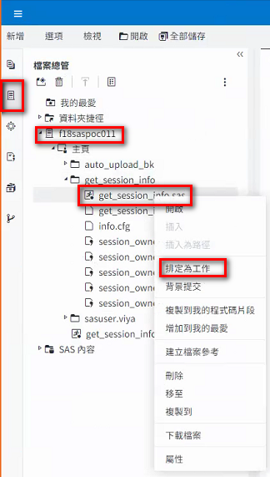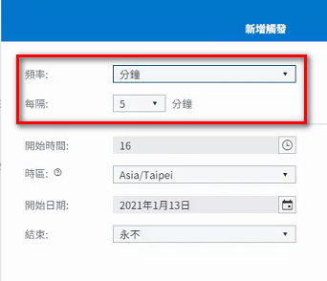

1. 等待五分鐘登入SAS Environment Manager -> Job(工作) 查看排程及運行結果

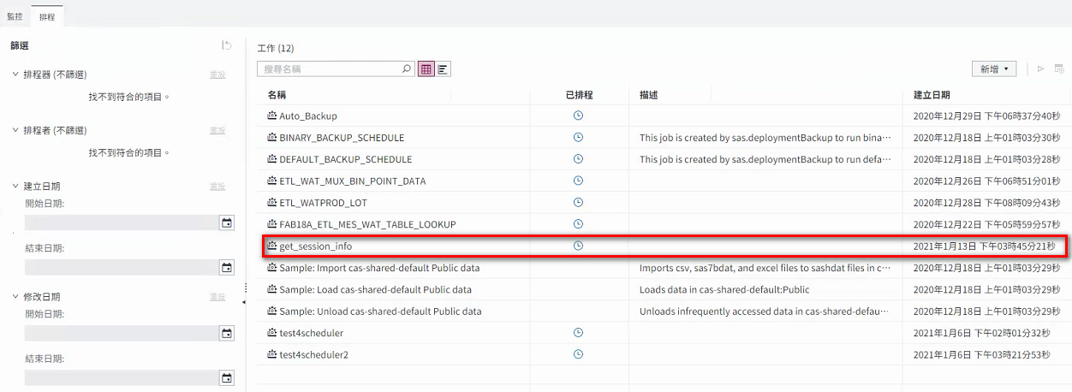

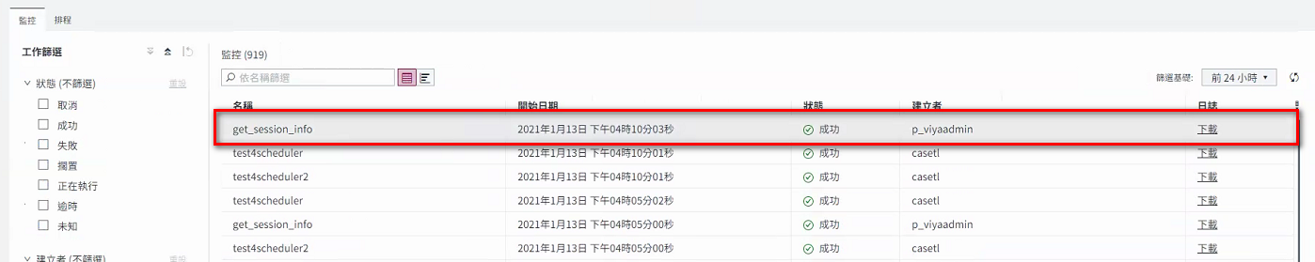

1. 登入SAS Environment Manager -> Data(資料) 查看cas-shared-default->public->session_owner被順利產出

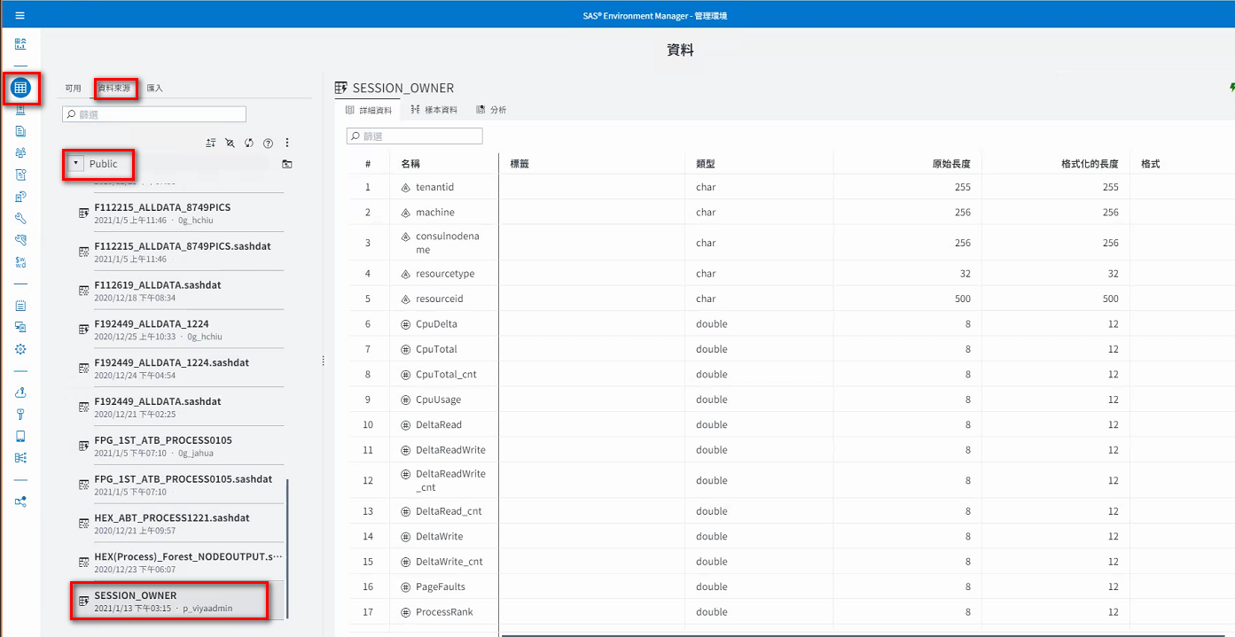

1. 至testing 環境 SAS Environment Manager 點選SAS Content-> Products -> SAS Environment Manager -> Dashboard Items ，右鍵’匯出’報表

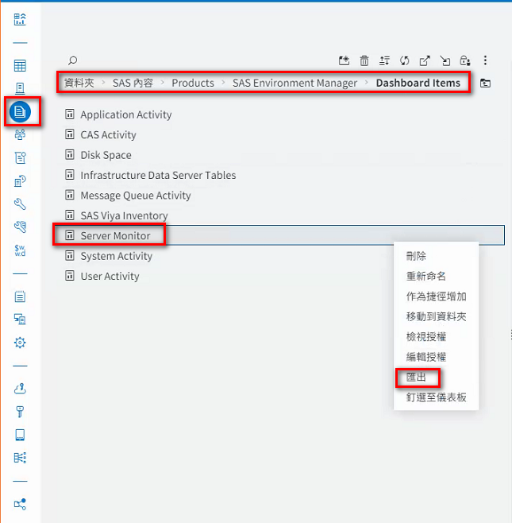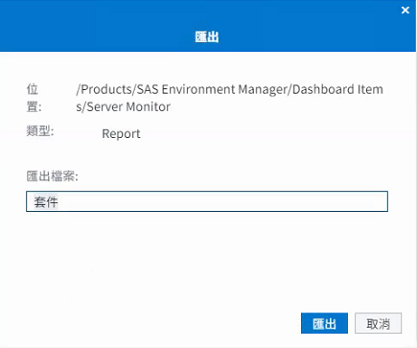

1. 至production

環境 SAS Environment Manager 點選SAS Content-> Products -> SAS Environment Manager -> Dashboard Items，匯入報表

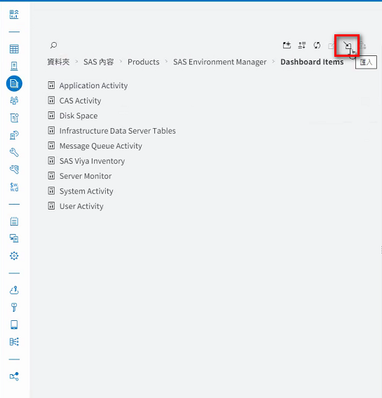

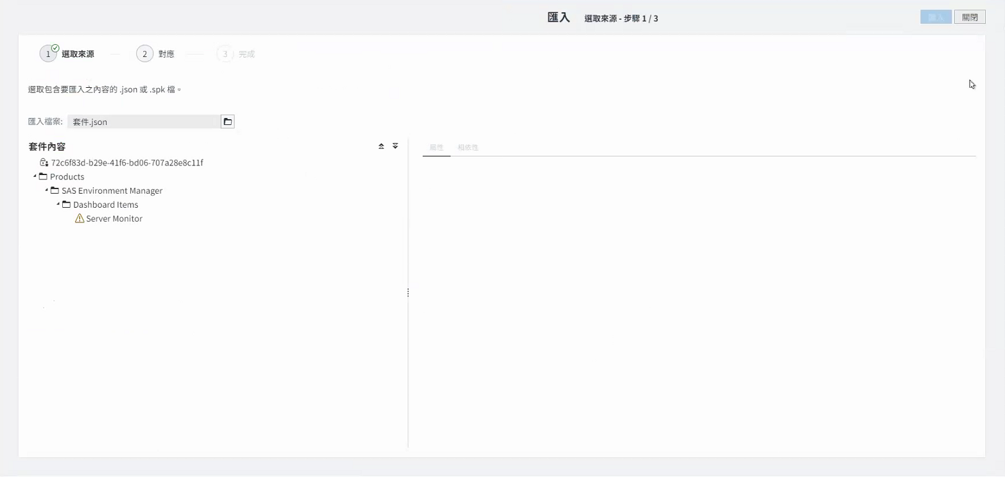

1. 切換至SASVisualAnalytics開啟報表

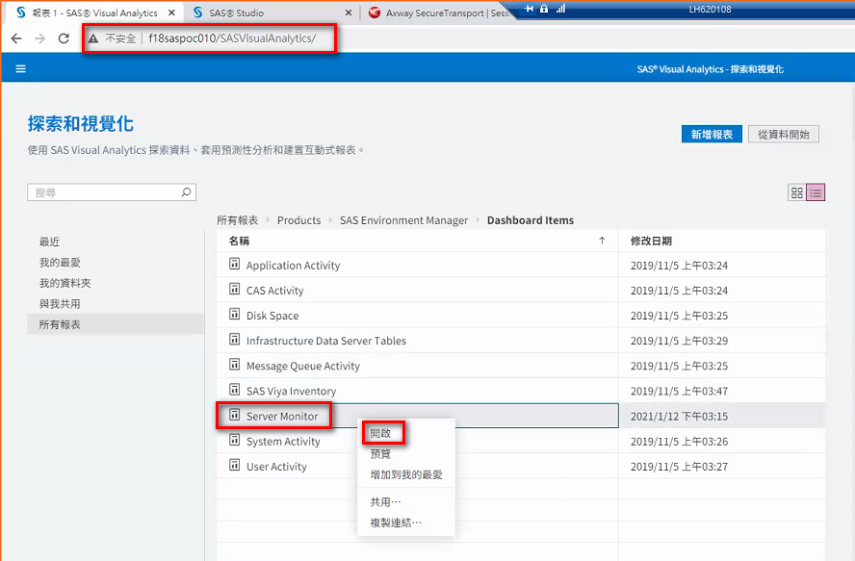

如果彈跳出視窗詢問是否自動採用最新的報表，選擇”否”，進入報表

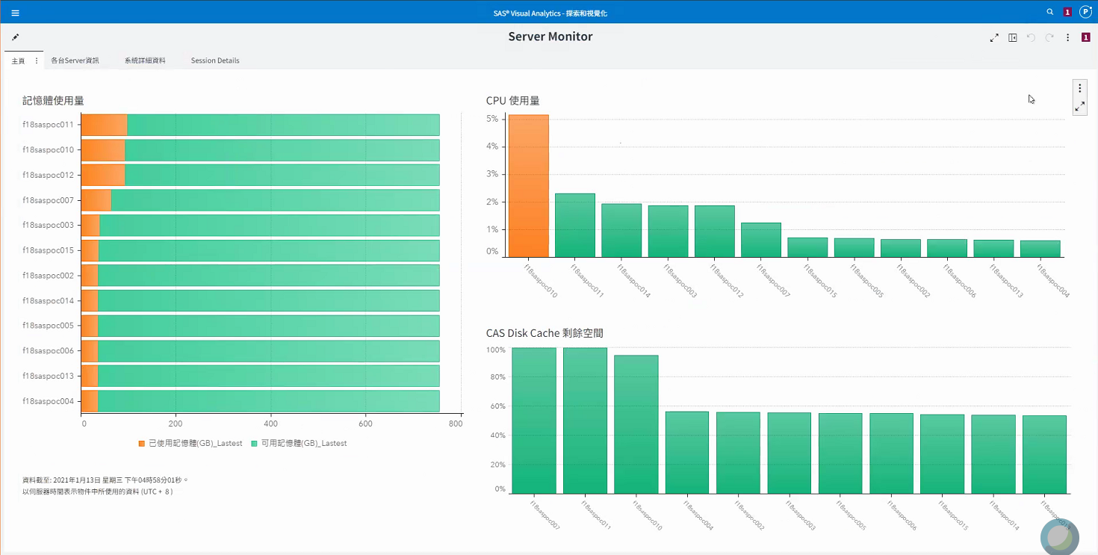

# **Viya服務管理**

此章節預設節點為control01, 目錄為sas_viya_playbook所在目錄,

此範例為/CREPOS/viya_35c/sas_viya_playbook,

透過viya-ark tools管理Viya服務

## 查詢Viya服務狀態

此方式需在sas-consul服務為啟動時使用

|  |
| --- |
| [root@control01 sas_viya_playbook]# ansible-playbook -i inventory.ini viya-ark/playbooks/viya-mmsu/viya-services-status.yml |

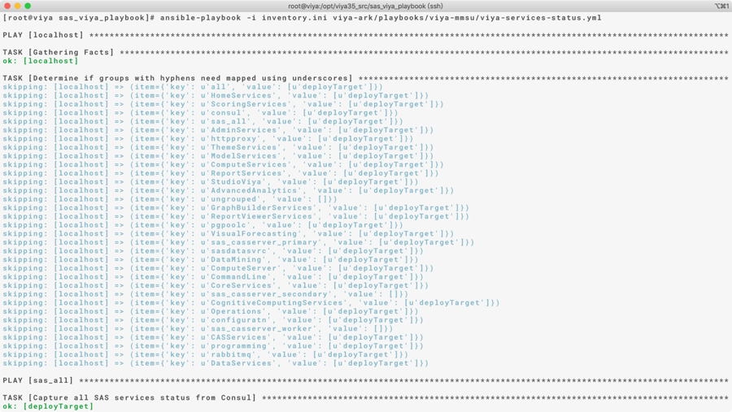

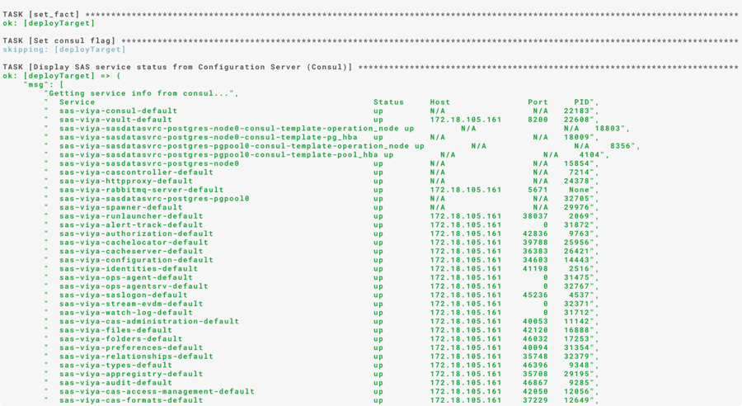

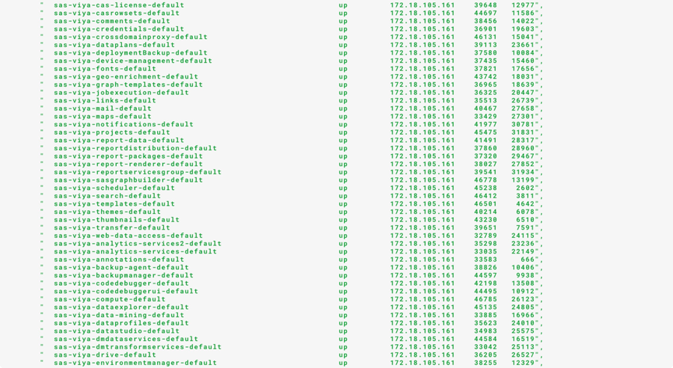

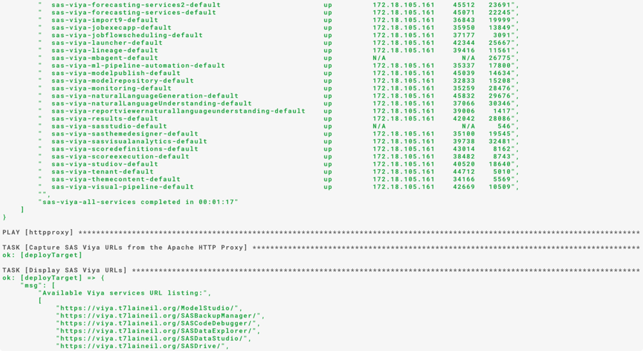

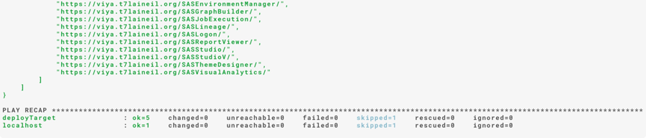

## 關閉Viya所有服務

如有停機需求, 停機前須先將所有服務關閉

|  |
| --- |
| [root@control01 sas_viya_playbook]# ansible-playbook -i inventory.ini viya-ark/playbooks/viya-mmsu/viya-services-stop.yml |

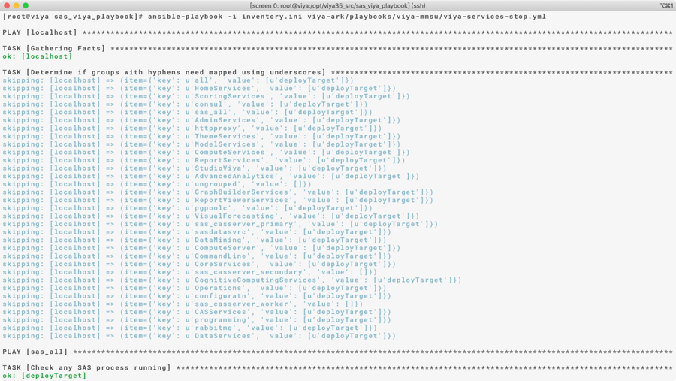

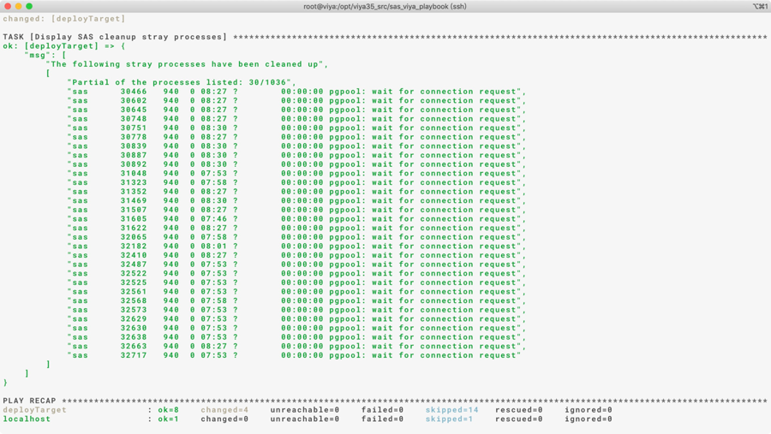

## 開啟Viya所有服務

重開機後需手動開啟所有服務

|  |
| --- |
| [root@control01 sas_viya_playbook]# ansible-playbook -i inventory.ini viya-ark/playbooks/viya-mmsu/viya-services-start.yml |

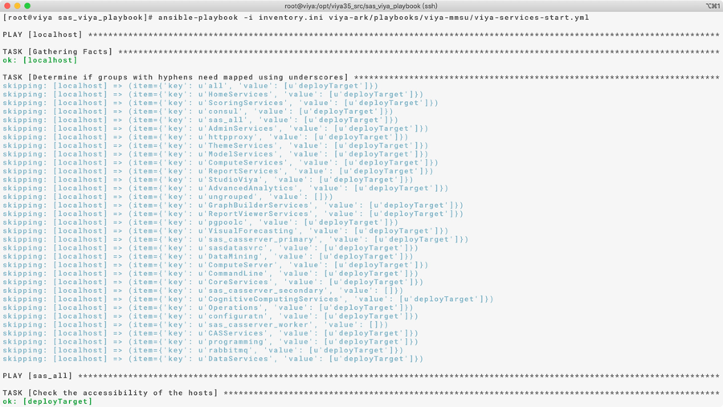

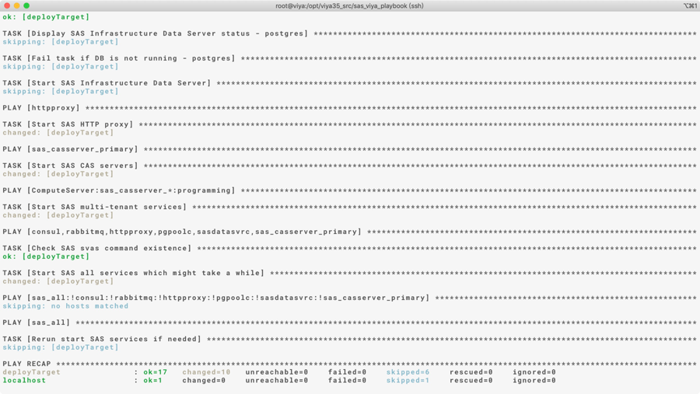

## 重啟Viya所有服務

|  |
| --- |
| [root@control01 sas_viya_playbook]# ansible-playbook -i inventory.ini viya-ark/playbooks/viya-mmsu/viya-services-restart.yml |

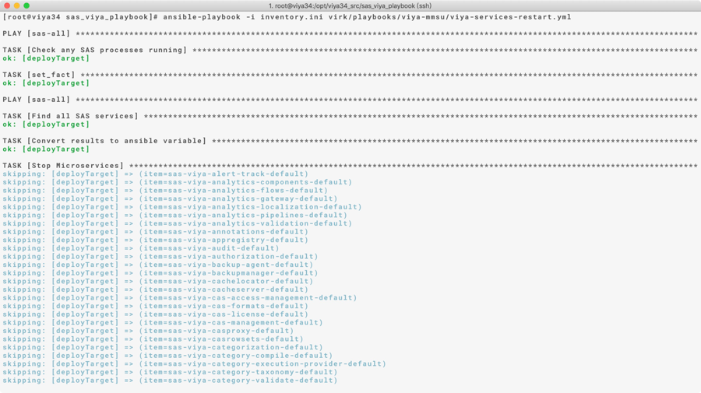

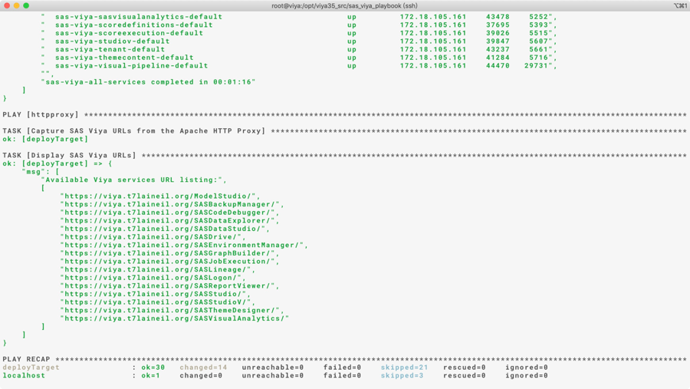

## Load CAS Tables

請至任一服務正常的micorservice server執行下列語法

[root@microservices01 /]# sh /SAS2/auto_upload_bk/load_table.sh

執行完成後可於/SAS2/Logs/load_parque_{yyyy.MM.dd_hh.mm.ss}.log中檢查執行結果。

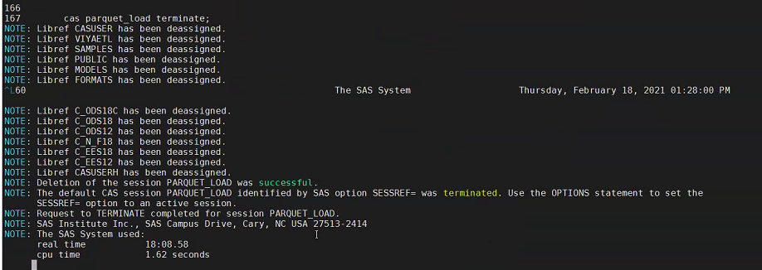

# **更新授權**

此章節為授權到期後新購買之授權更新,

授權檔為.jwt及.txt檔案各一份,

以下為授權到期示意圖

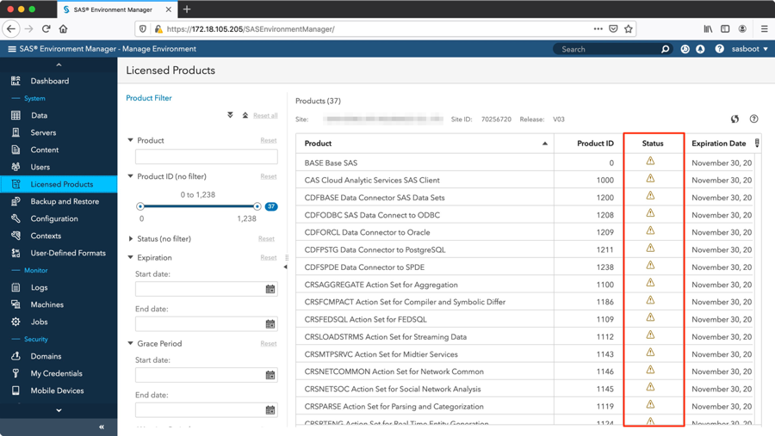

## 上傳新授權

將新授權檔放入sas_viya_playbook所在目錄夾中,

本範例為/CREPOS/viya_35c/sas_viya_playbook

|  |
| --- |
| [root@control01 sas_viya_playbook]# ls -ltr |

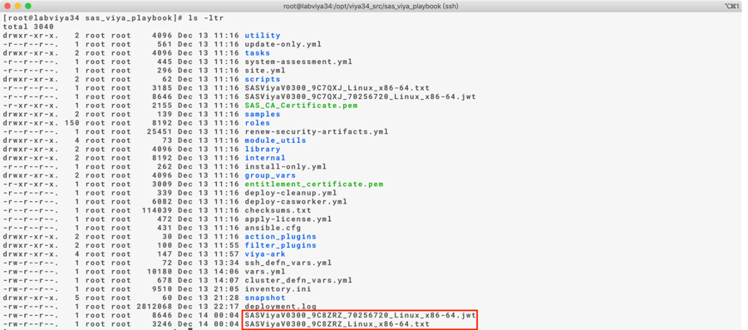

## 修改vars.yml

將vars.yml修改為新授權

|  |
| --- |
| [root@control01 sas_viya_playbook]# vim vars.yml  LICENSE_FILENAME: "SASViyaV0300_9C8ZRZ_Linux_x86-64.txt"  # LICENSE_FILENAME: "*[new_license.txt]*”  LICENSE_COMPOSITE_FILENAME: "SASViyaV0300_9C8ZRZ_70256720_Linux_x86-64.jwt"  # LICENSE_COMPOSITE_FILENAME: "*[new_license.jwt]*" |

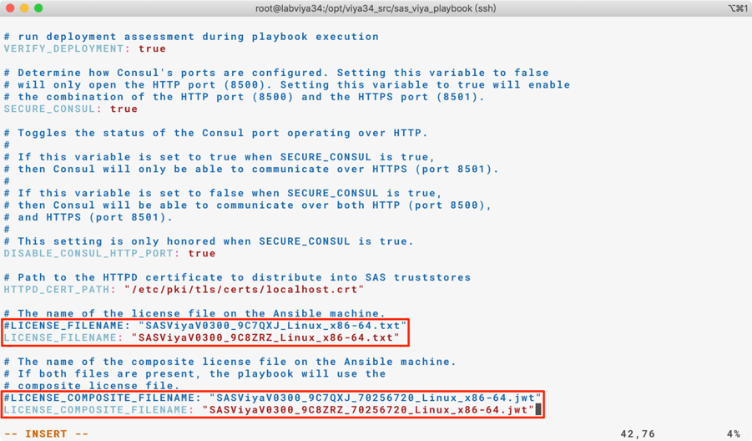

## 啟用新授權

apply license

|  |
| --- |
| [root@control01 sas_viya_playbook]# ansible-playbook apply-license.yml |

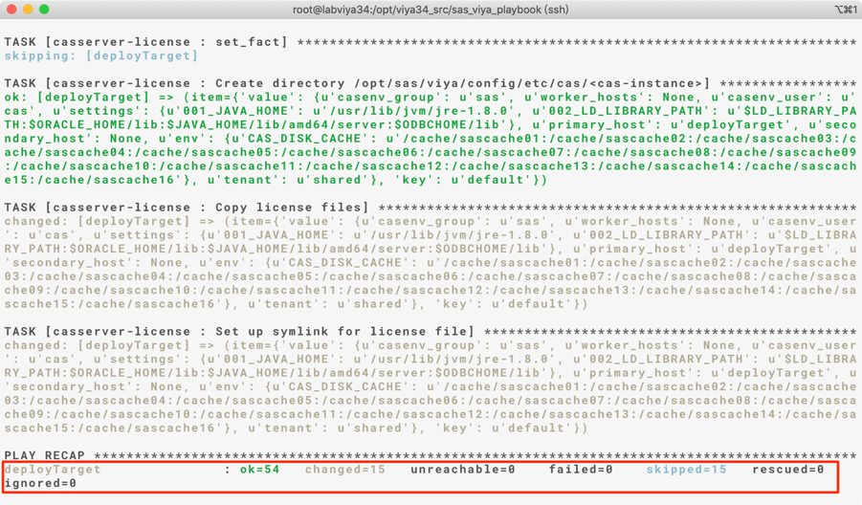

參照章節5.4重啟Viya所有服務

驗證授權更新

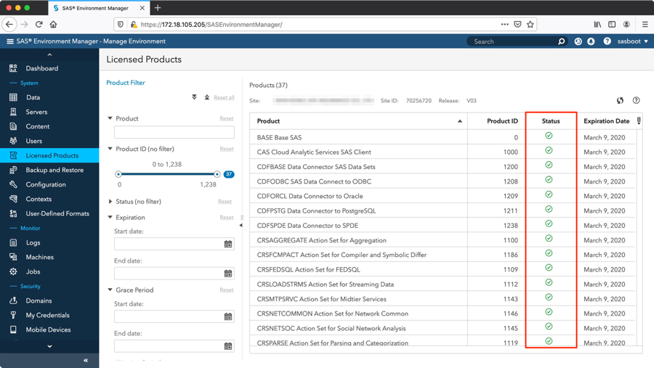

# **NAS更換步驟**

## Stop all viya service(control01)

5.2 關閉Viya所有服務

## Mount new NAS and change owner(control01)

將新NAS mount on /CREPOS_new

|  |
| --- |
| [root@control01 ~]# chown sas:sas /CREPOS_tmp |

## Copy files(control01)

|  |
| --- |
| [root@control01 ~]# rsync -avP /CREPOS* /CREPOS_tmp |

## Set up NAS(control01,control02)

* umount /CREPOS及/CREPOS_tmp
* mount New NAS to /CREPOS
* 刪除 /CREPOS_tmp暫時目錄

## Start viya service(control01)

4.3 開啟Viya所有服務

## Revised /etc/fstab(control01,control02)

修改/etc/fstab檔案內/CREPOS mount point的NAS IP,

換成新的 NAS IP

# **Error Logs查詢**

此章節為系統運行上有錯誤時查詢Logs使用

## SAS Environment Manager Los

使用管理者登入SAS Environment Manager, 此處範例以sasboot為例





點選左上角””=>點選”Manager Environment”

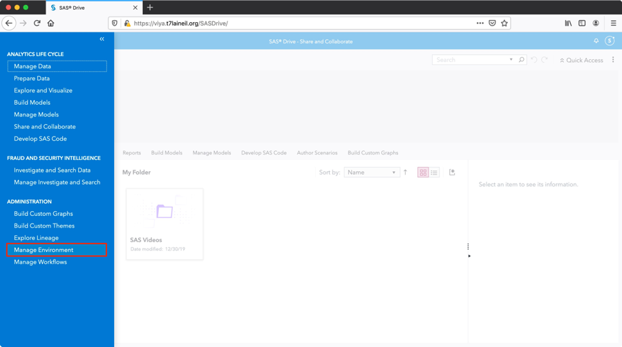

點選Logs=>點選ERROR查詢Logs

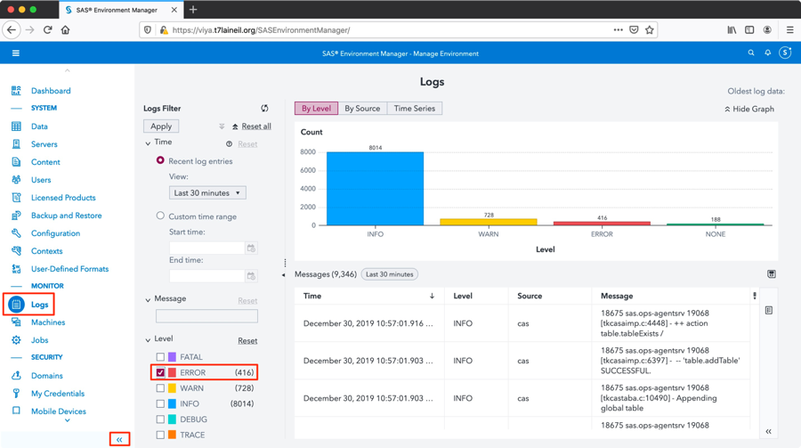

## SAS Server Logs

使用root登入Server, SAS Viya相關的Logs在Server上的目錄為

/var/log/sas/viya/*[service_name]*/default/*[xxx_.log]*

|  |
| --- |
| [root@viya ~]# grep ERROR /var/log/sas/viya/*/default/* |

## Log Collection Script

為了方便User操作，客製一支蒐集log的collect.sh放置於/CREPOS/log_collect/，蒐集的log會放置於/CREPOS/Logs/log_collect

|  |  |  |  |
| --- | --- | --- | --- |
| Script名稱 | Script功能 | 排程Server | 排程時間 |
| collect.sh | 手動執行蒐集server上的log | None | None |
| collect.yml | 含括在collect.sh裡面，蒐集service的log | None | None |
| collect-mes.yml | 含括在collect.sh裡面，蒐集server的/var/log/message | None | None |

使用方式如下:

./collect.sh => Fetch today CAS,Messages,Compsrv,NTP logs

        ./collect.sh -l compute => Fetch todays specify logs

        ./collect.sh -d 2020-01-12 => Fetch specify days CAS,Messages,Compsrv,NTP logs

        ./collect.sh -d 2020-01-12 -l compute => Fetch specify days logs

        ./collect.sh -l compute -d 2020-01-12 => Fetch specify days logs